**VANITY**

**Members:  
Validor,Juliana Arwen D. - Coding**

**Rio, Bryan Carl - details of the system**

**Bacon, Kurt - idk yet**

**Gerunda, Marion - idk yet**

## **Ordering Make-Up System Overview**

This system is an online platform where users can browse, order, and manage different make-up products from well-known brands such as **Sephora**, **MAC**, **Maybelline**, **Olay**, and **L’Oréal**. It supports both desktop and mobile layouts, and focuses on easy ordering, pricing accuracy, and proper record-keeping through a database.

## **Key Features**

### **1. User Authentication**

* New users register through a **Sign-Up** page.
* Existing users log in using a **Login** page.
* Each account gets a **unique User ID**.
* Login allows access to the ordering system and personal order history.

### **2. Product Ordering (5 Brands)**

The system displays products from:

* Sephora
* MAC
* Maybelline
* Olay
* L’Oréal

Each product includes:

* Product name
* Brand
* Unit price
* Stock availability
* Add-to-cart option

Users can order any combination of products from the five brands.

### **3. Inventory Management**

* The system tracks available stock for each product.
* When a user orders, stock automatically decreases.
* Admin can update or restock inventory.

### **4. Price Computation**

Every order automatically calculates:

* Item price × quantity
* Subtotal
* Shipping fee
* Tax
* Final total cost

**Total Cost = Subtotal + Shipping Fee + Tax**

This ensures transparency before the customer checks out.

### **5. Checkout & Transaction Handling**

During checkout, the system:

* Displays full order summary
* Calculates total cost with fees
* Confirms purchase
* Generates a **Transaction ID**
* Saves the purchase to the database

### **6. Order Database**

The database stores:

* User information
* Product list
* Inventory stock
* Purchase transactions
* Each user's orders linked to their unique User ID
* Date/time of each purchase
* Total paid amount including fees

This allows users to view their past orders and admins to track sales.

## **7. User Purchase History**

Logged-in users can see:

* All products they bought
* Prices and quantities
* Final cost per transaction
* Status (delivered, pending, cancelled)

## **System Languages & Tools**

* **Backend:** PHP, Laravel, Breeze
* **Frontend:** HTML, CSS
* **Database:** MariaDB / SQL

**8. Categories OR WHATEV**

**MAC**

**Makeup**

* **Foundations**

**Studio Fix Fluid SPF 15 24HR Matte Foundation + Oil Control**

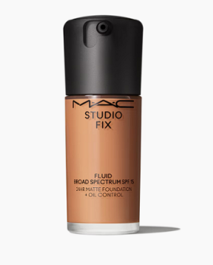

# **Studio Radiance Serum-Powered™ Foundation**

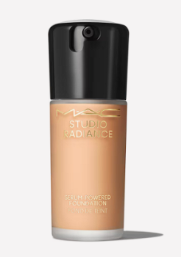

# **Studio Radiance Face and Body Radiant Sheer Foundation**

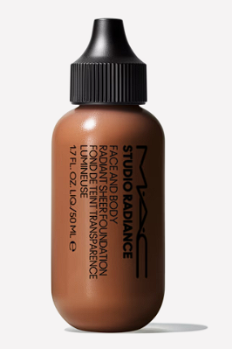

**M·A·C Studio Face and Body Foundation 120 ml**

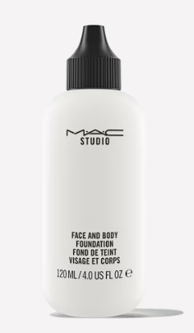

# **Full Coverage Foundation**

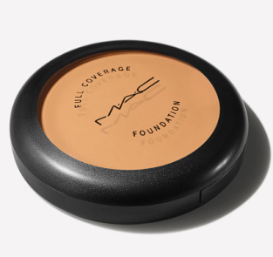

# **Studio Fix Tech Cream-To-Powder Foundation**

# 

# 

# 

# 

# 

# 

# **Pro Palette Full Coverage Foundation x 12**

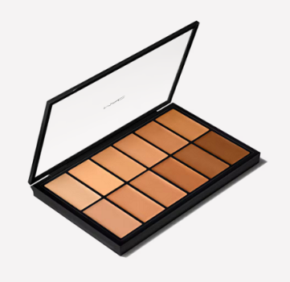

# **Strobe Dewy Skin Tint Moisturizer**

* **Concealers**

**Studio Fix 24-Hour Smooth Wear Concealer**

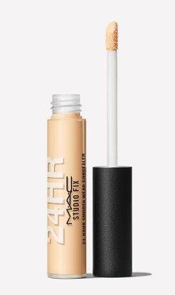

**STUDIO RADIANCE 24HR LUMINOUS LIFT CONCEALER**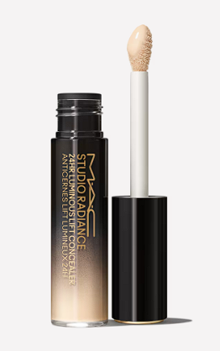

**Pro Longwear Concealer**

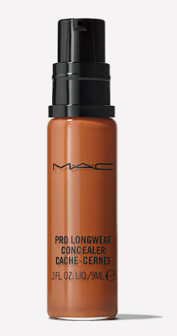

# 

# 

# 

# 

# 

# **Studio Fix Every-Wear All-Over Face Pen**

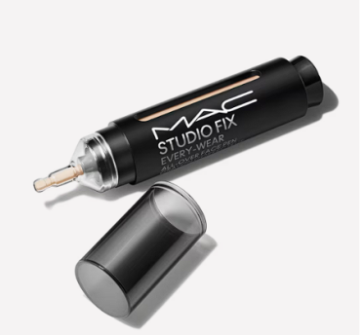

# **Studio Fix Conceal and Correct Palette**

**Powders**

# 

# 

# 

# 

# **Studio Fix Pro Set + Blur Weightless Loose Powder**

# 

# 

# 

# 

# 

# **Weightless Loose Powder**

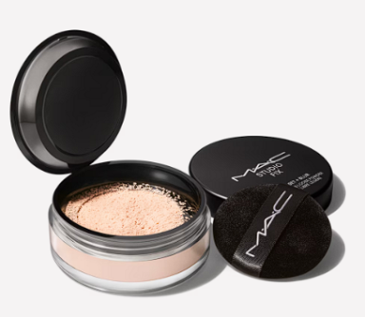

**Mineralize Skinfinish**

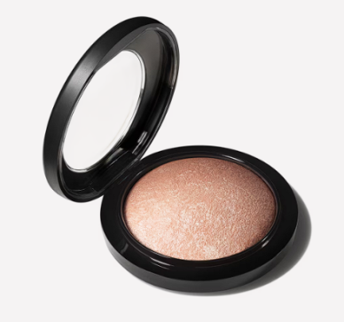

**Mineralize Skinfinish Natural Face Powder**

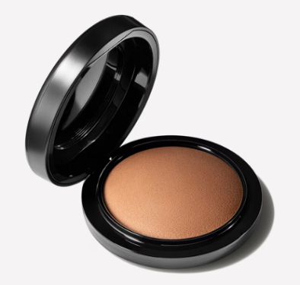

# **Blot Powder / Pressed**

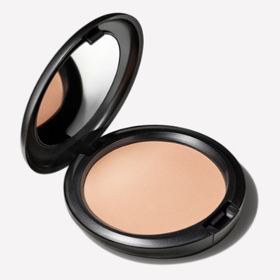

* **Highlighters**

**Extra Dimension Skinfinish Highlighter**

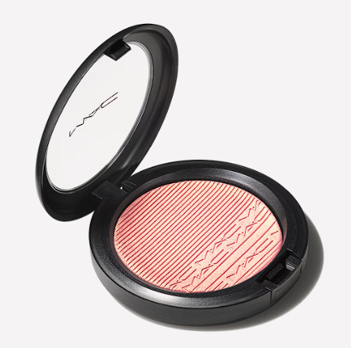

# 

# **Skinfinish Lightstruck Liquid Highlighter**

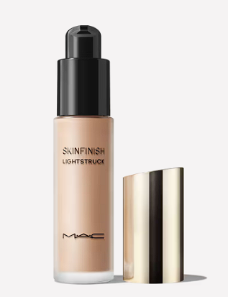

**Surreal Shine Mini Highlighter Duo**

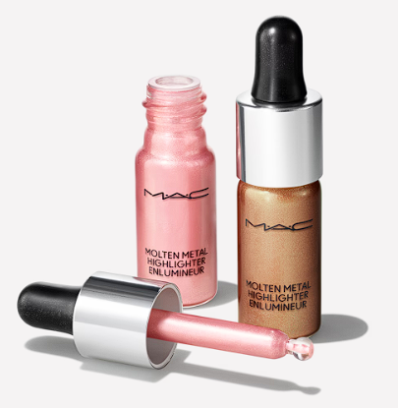

**Bounce & Gleam Highlighter / M·A·C Holiday**

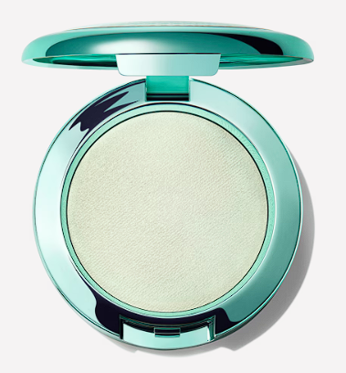

**Cream Colour Base Highlighter**

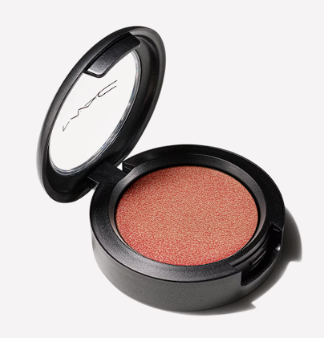

* **Lipsticks**

**M·A·CXIMAL SLEEK SATIN LIPSTICK**

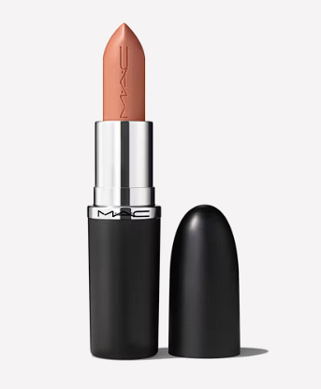

**LUSTREGLASS SHEER-SHINE LIPSTICK / M·A·C X DISNEY MINNIE & DAISY**

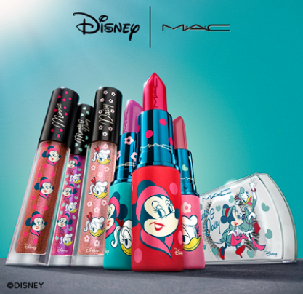

**M·A·CX TO THE FUTURE LIP TRIO**

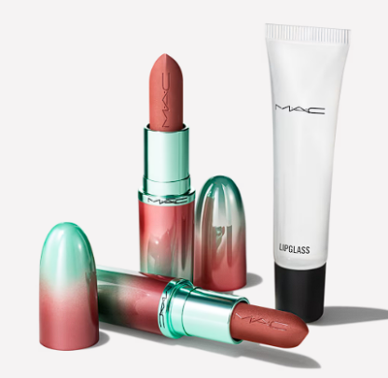

**Powder Kiss Liquid Lipcolour**

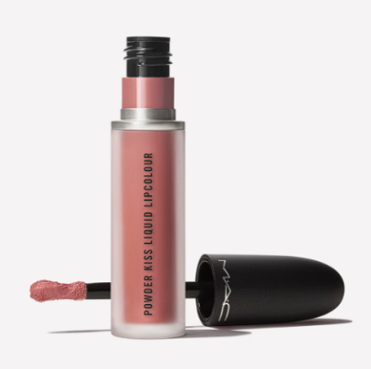

**Retro Matte Liquid Lipcolour**

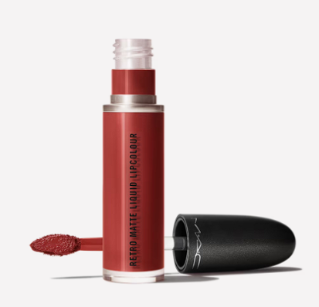

**Powder Kiss Lipstick**

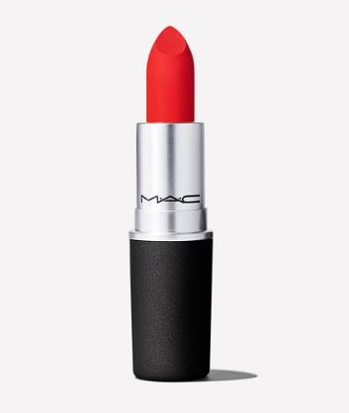

# **Retro Matte Liquid Lipcolour Metallics**

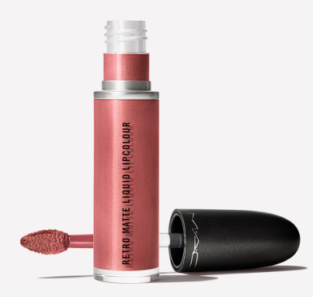

**Powder Kiss Lipstick**

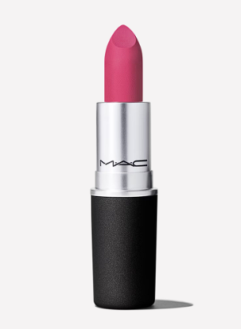

**Powder Kiss Velvet Blur Slim Stick**

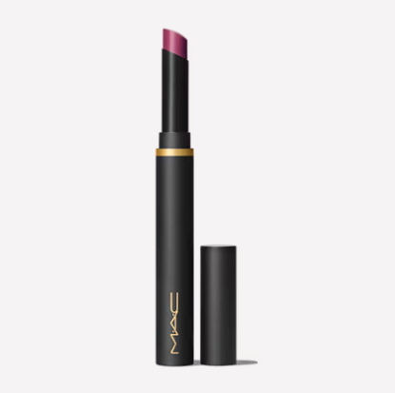

**M·A·C Locked Kiss Ink 24HR Lipcolour**

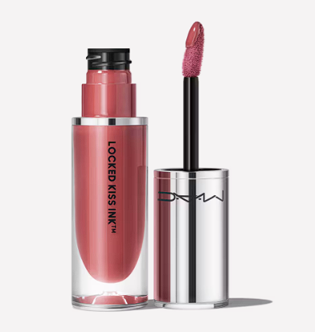

* **Lip Gloss**

**Lipglass Air Non-Sticky Gloss**

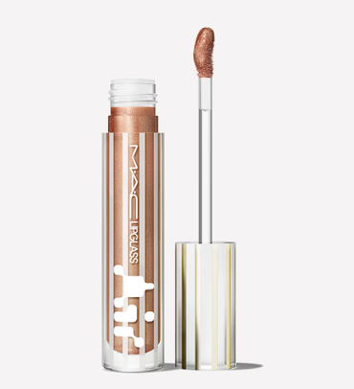

# **LIPGLASS / M·A·C X DISNEY MINNIE & DAISY**

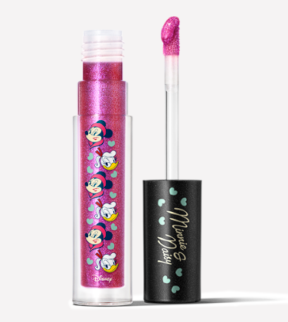

**LIPGLASS AIR NON-STICKY GLOSS / M·A·C Holiday**

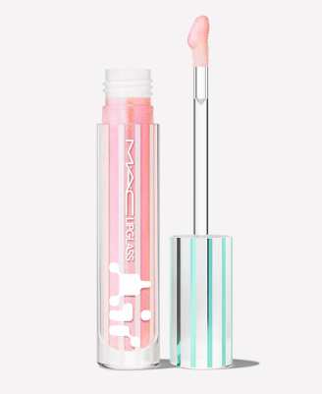

# **Lipglass Air Non-Sticky Gloss / Nocturna**

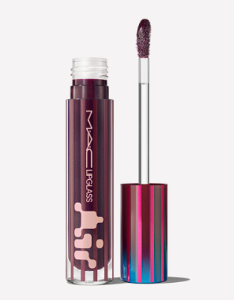

**Lipglass Blow Plumping Oil**

# 

**Viva Glam Lipglass Air**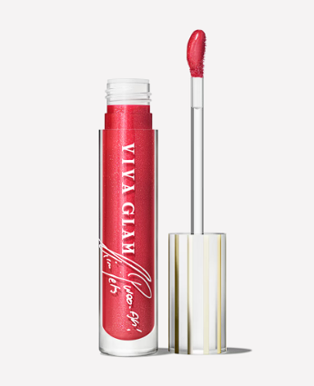

# **Sugar Crystal Lip Oil Stick / M·A·C Holiday**

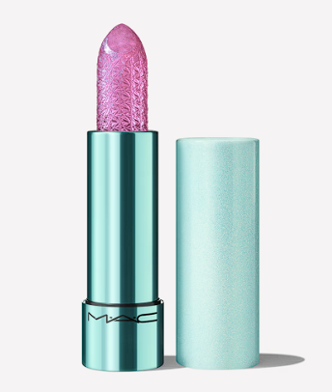

* **Eyeshadows**

**Eye Shadow Glitter**

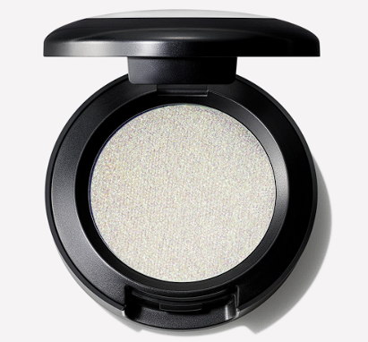

**Dazzleshadow Liquid Eye Shadow**

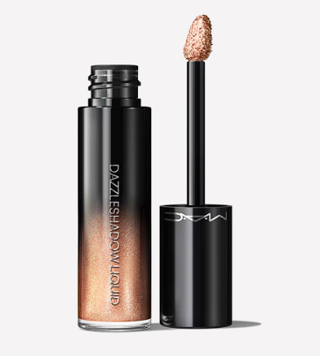

**M·A·Cnificent Eye Shadow Palette x 6**

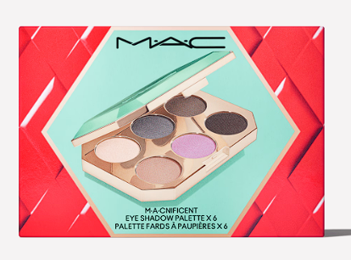

**Connect In Colour Eye Shadow Palette: Encrypted Kryptonite**

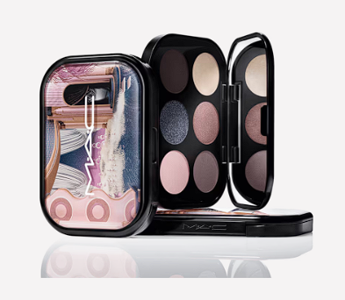

# **Connect In Colour Eye Shadow Palette: Future Flame**

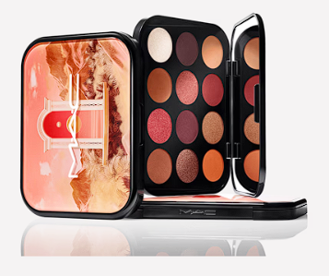

**Connect In Colour Eye Shadow Palette: Hi-Fi Colour**

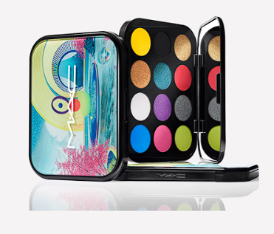

**Connect In Colour Eye Shadow Palette: Rose Lens**

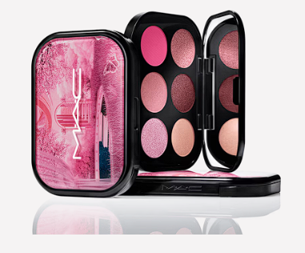

**Pigment**

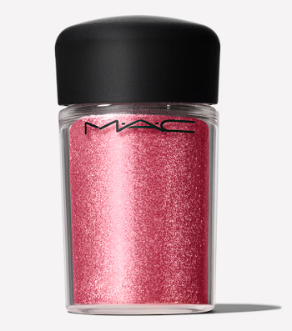

# **Dazzleshadow Eye shadow Sticks**

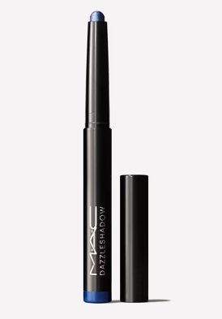

**Dazzleshadow Liquid / Luxe Luck**

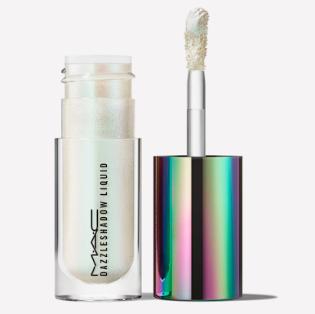

* **Mascaras**

**M·A·CStack Elevated Mascara**

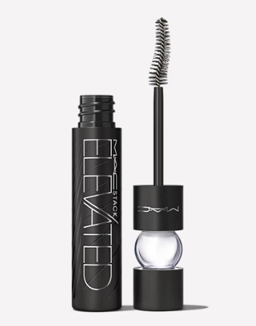

**Stacked To The Max M·A·CStack Lash Duo**

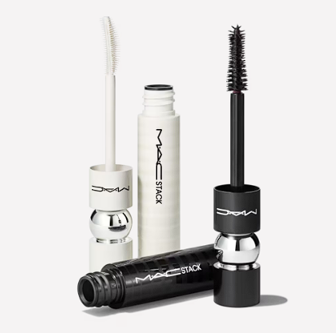

**M·A·CStack Volumizing Mascara**

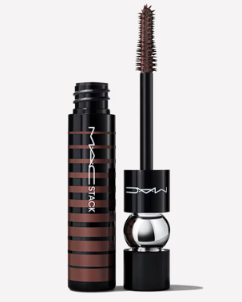

**Lash Dry Shampoo Mascara Refresher**

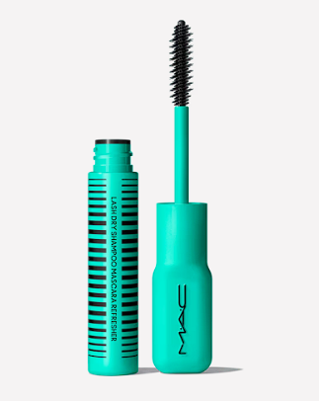

**Extended Play Gigablack Lash Mascara**

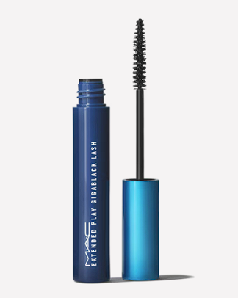

**M·A·CSTACK Legit Lift Lash Primer**

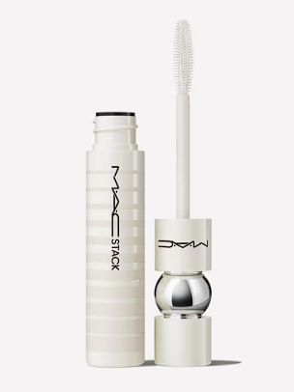

**M·A·CStack Elevated Mascara / Nocturna**

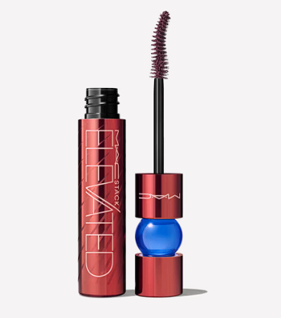

* **Brows**

**Pro Brow Definer 1mm-Tip Brow Pencil**

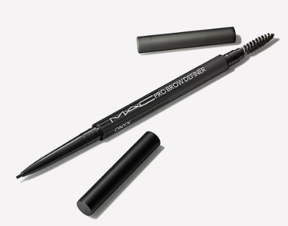

**Pro Locked Brow Gel**

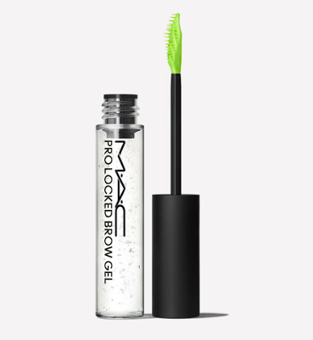

**Tinted Eye Brows Big Boost Fibre Gel**

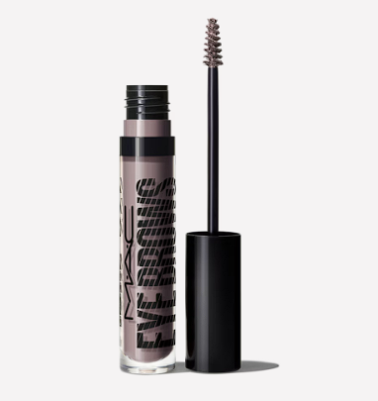

* **Eyeliner**

# **M·A·C Colour Excess Gel Pencil Eye Liner**

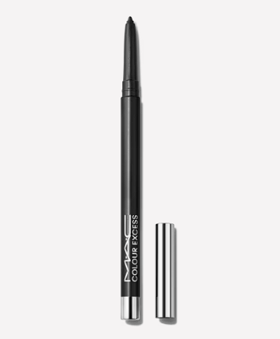

**In Extreme Dimension 24-Hour Kajal Eye Liner / Nocturna**

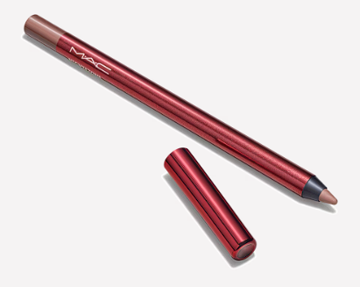

### 

### **Brushstroke 24-Hour Liner**

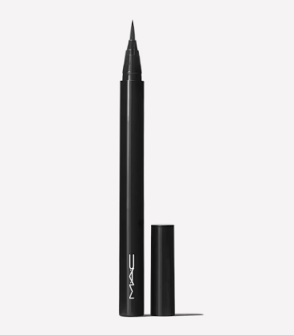

**Eye Kohl Eyeliner**

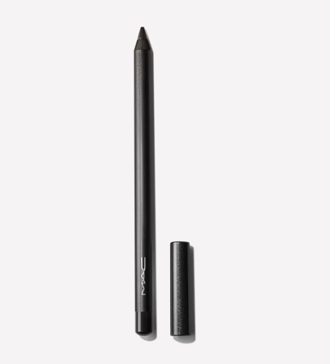

**Pro Longwear Fluidline Eye Liner And Brow Gel**

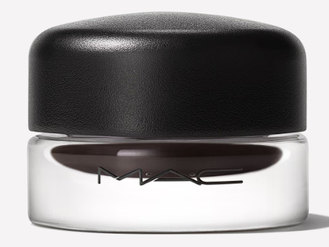

### 

### 

**Primers & Prep**

* **Face Primers**

**Studio Radiance Moisturizing + Illuminating Silky Primer**

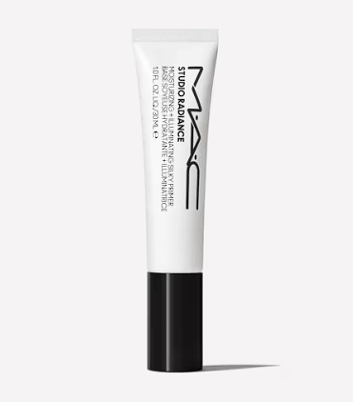

**Studio Fix Mattifine 12hr Shine-Control Primer**

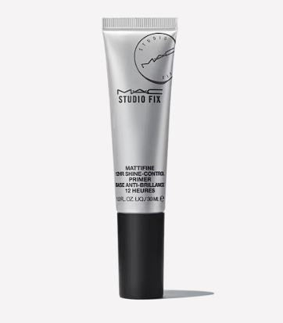

**Prep + Prime Face Protect Lotion SPF 50**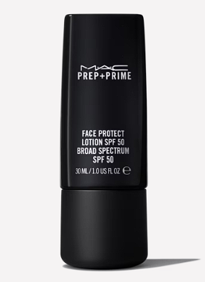

**Prep + Prime Natural Radiance**

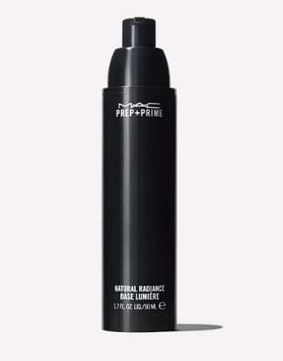

**Mineralize Timecheck Lotion**

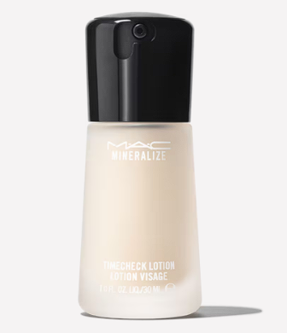

* **Eye Primers**

**Fast Response Eye Cream**

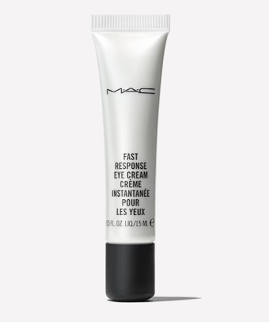

**Prep + Prime 24-Hour Extend Eye Base**

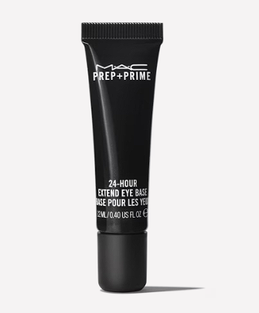

# **Hyper Real Serumizer™ Eye 360° Bright Eye Treatment**

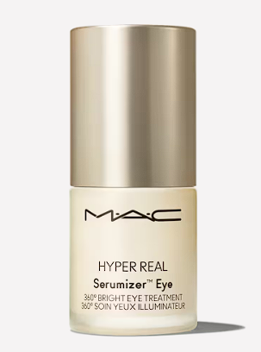

* **Lip Primers**

**GLOWPLAY TENDERTALK LIP BALM**

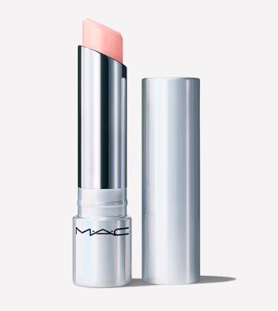

# **Squirt Plumping Gloss Stick**

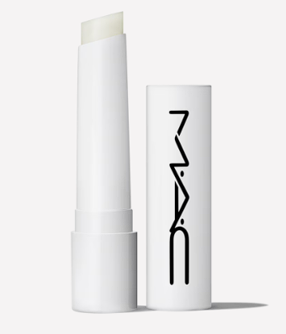

**Prep + Prime Lip | Lip Primer Base**

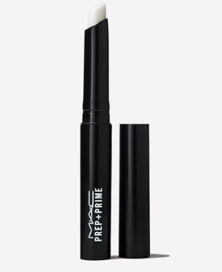

**Lip Conditioner (Tube) | Hydrating Lip Balm**

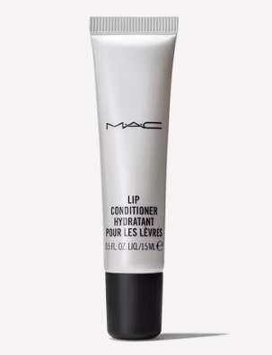

* **Setting Sprays**

**FIX+ Setting Spray**

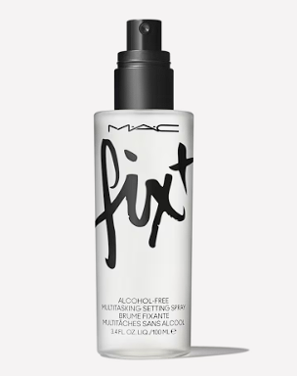

**FIX+ MAGIC RADIANCE - Setting Spray**

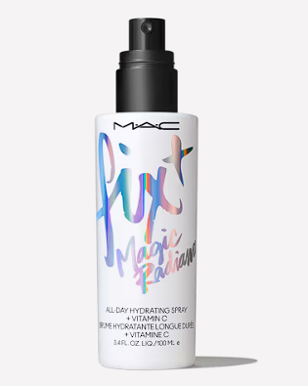

# **Fix+ Stay Over Alcohol-Free 24HR Setting Spray**

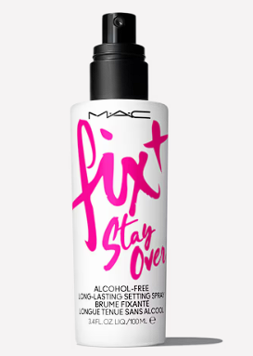

### 

### 

### 

### 

### **Prep + Prime Fix+ Matte**

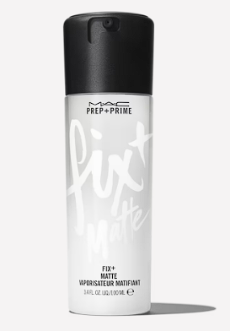

### **Skincare**

* **Cleansers + Makeup Removers**

# **Hyper Real Fresh Canvas Cleansing Oil**

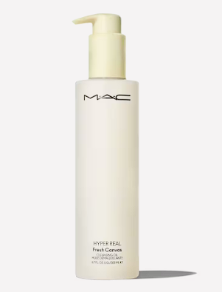

**Hyper Real Fresh Canvas Cream-To-Foam Cleanser**

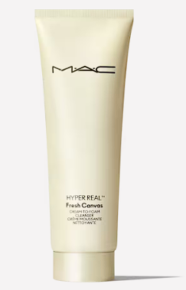

* **Serums + Treatments**

# **Hyper Real Serumizer™ Skin Balancing Hydration Serum**

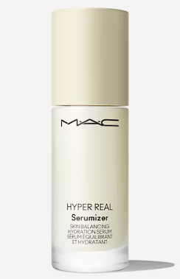

**Hyper Real Serumizer™ Eye 360° Bright Eye Treatment**

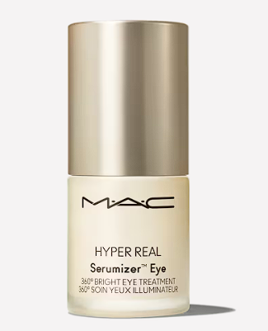

**Prep + Prime Essential Oils Grapefruit & Chamomile**

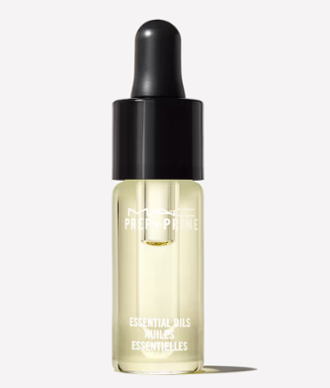

* **Moisturizers**

**Strobe Cream | Moisturizer + Highlighter  
 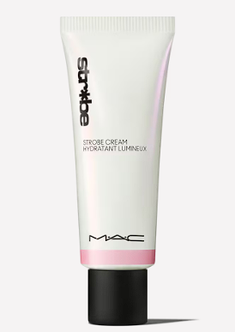**

**Hyper Real SkinCanvas Balm™ Moisturizing Cream**

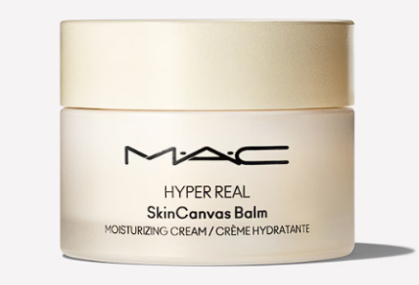

**Strobe Cream / Mini M·A·C**

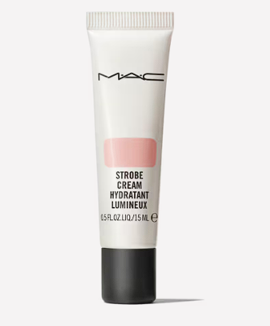

**Tools**

* **Brushes**

# **M·A·C Of All Trades Brush Kit**

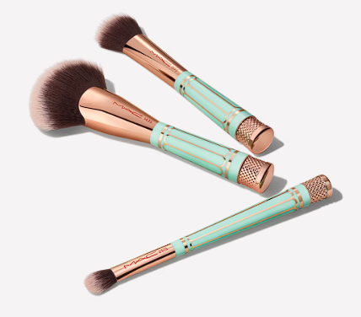

# **210 Synthetic Precise Eye Liner Brush**

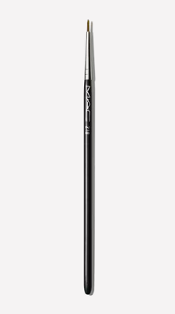

# **221 Synthetic Mini Tapered Blending Brush**

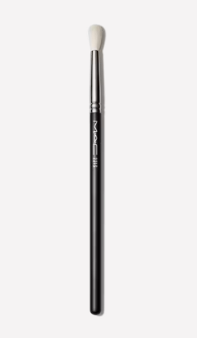

**239 Synthetic Eye Shader Brush**

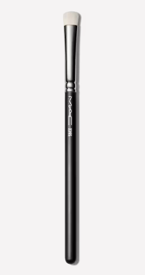

**263 Synthetic Small Angle Brush**

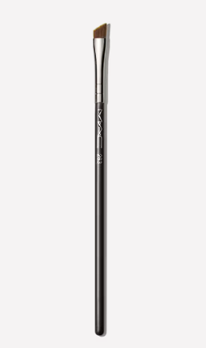

# 

# **286 Synthetic Duo Fibre Tapered Brush**

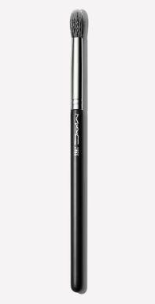

# **001 Serum + Moisturizer Brush**

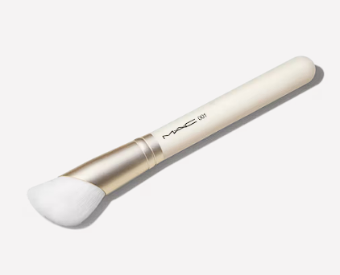

**143S Bronzer Fan Brush**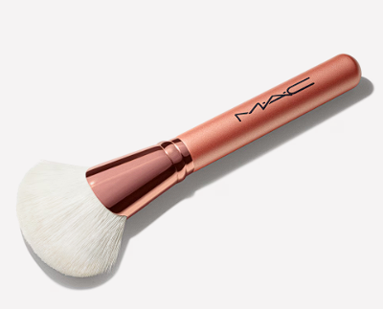

# **128 Synthetic Split Fibre Cheek Brush**

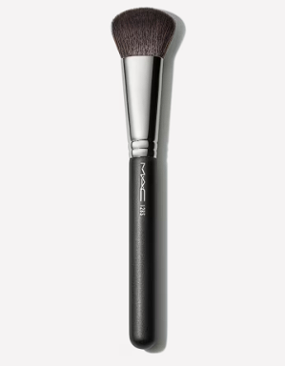

**137 Synthetic Long Blending Brush**

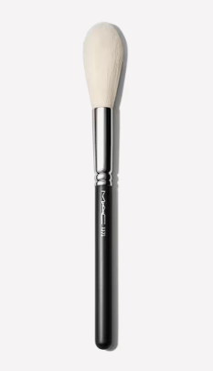

**184 Synthetic Duo Fibre Fan Brush**

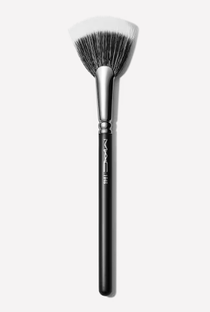

**270 Synthetic Mini Rounded Slant Brush**

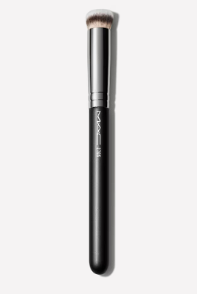

**190 Synthetic Foundation Brush**

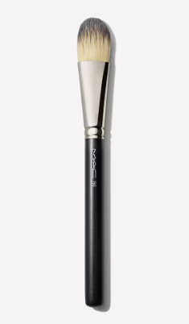

**191 Square Foundation Brush**

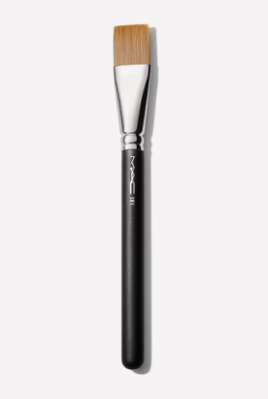

* **Sponges**

**Beautyblender Original**

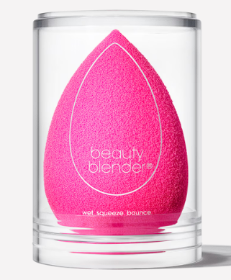

* **Brush Cleaners**

**Brush Cleanser**

# 

**L’ORÉAL PARIS**

**Makeup**

* **Foundation & Concealer**

[Infallible](https://www.lorealparis.com.ph/face-makeup/infallible) 32HR Matte Cover Foundation 32HR Matte Cover Foundation 105 Fair Linen

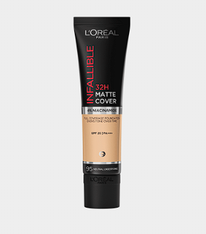

[Infallible](https://www.lorealparis.com.ph/face-makeup/infallible) 32H Fresh Wear Foundation

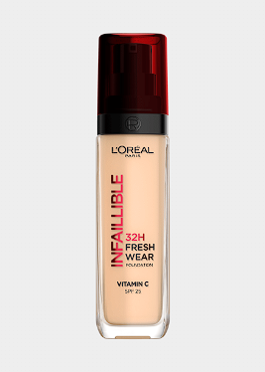

[Infallible](https://www.lorealparis.com.ph/face-makeup/infallible) [Full Wear Concealer Full Wear Concealer](https://www.lorealparis.com.ph/face-makeup/infallible)

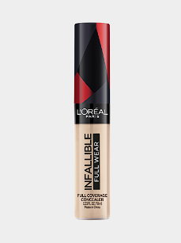

[Infallible](https://www.lorealparis.com.ph/face-makeup/infallible) [More Than Concealer](https://www.lorealparis.com.ph/face-makeup/infallible)

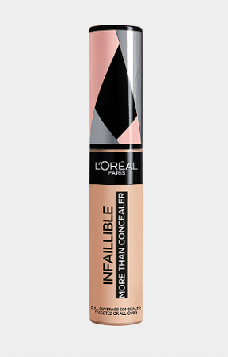

[Infallible](https://www.lorealparis.com.ph/face-makeup/infallible) [24HR Fresh Wear Powder Foundation](https://www.lorealparis.com.ph/face-makeup/infallible)

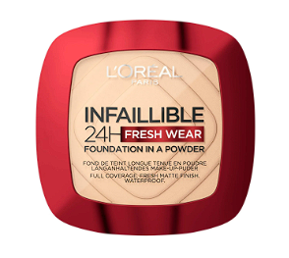

* **Mascara & Eye Makeup**

**[Voluminous Panorama Waterproof Mascara](https://www.lorealparis.com.ph/eye-makeup/voluminous)**

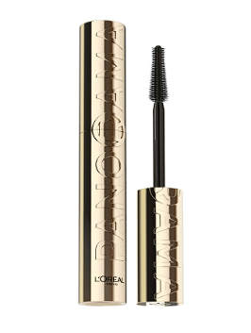

**[VoluminousLash Paradise Waterproof Mascara](https://www.lorealparis.com.ph/eye-makeup/voluminous)**

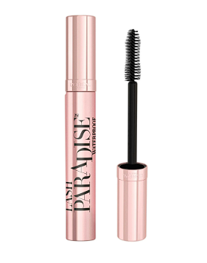

* **Lipsticks & Lip Liners**

**[Infallible Matte Resistance 16HR Liquid Lipstick](https://www.lorealparis.com.ph/lip-makeup/infallible)**

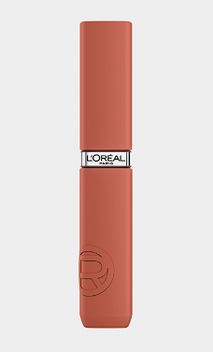

**[Chiffon SignatureSoft Blur Lip Tint](https://www.lorealparis.com.ph/lip-makeup/chiffon-signature)**

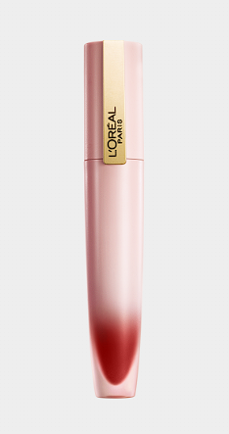

**[Rouge SignatureBaked Nudes Baked Nudes Matte Lip Tint Liquid Lipstick](https://www.lorealparis.com.ph/lip-makeup/rouge-signature)**

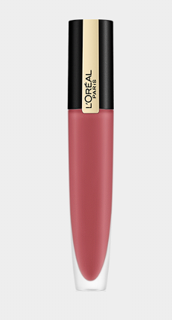

**[Rouge SignatureEmpoweREDS EmpoweREDS Matte Lip Tint Liquid Lipstick](https://www.lorealparis.com.ph/lip-makeup/rouge-signature)**

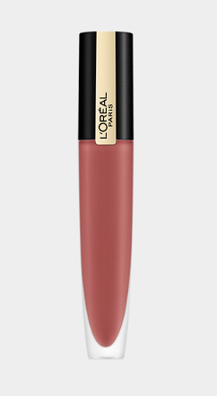

**[Rouge SignatureMatte Lip Tint Liquid Lipstick](https://www.lorealparis.com.ph/lip-makeup/rouge-signature)**

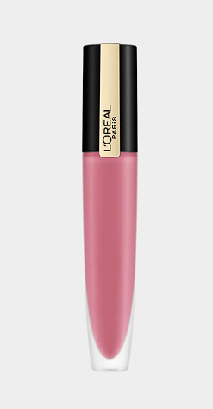

**Skincare**

* **Cleansers**

**[Glycolic BrightGlowing Daily Cleanser Foam 100ml](https://www.lorealparis.com.ph/skin-care/glycolic-bright)**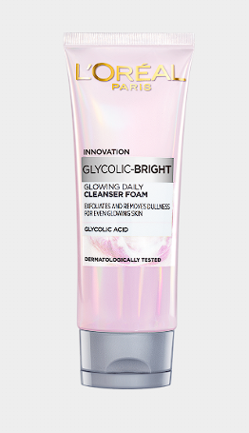

**[Glycolic BrightAnti-Dark Spot UV Fluid](https://www.lorealparis.com.ph/skin-care/glycolic-bright)**

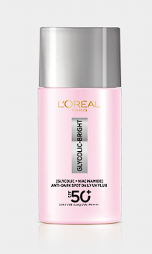

**[RevitaliftHyaluronic Acid Hydrating Gentle Gel Cleanser 100mL](https://www.lorealparis.com.ph/skin-care/revitalift)**

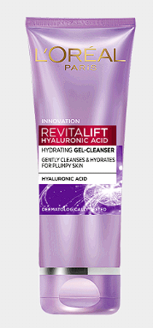

**[RevitaliftMilky Foam 100mL](https://www.lorealparis.com.ph/skin-care/revitalift)**

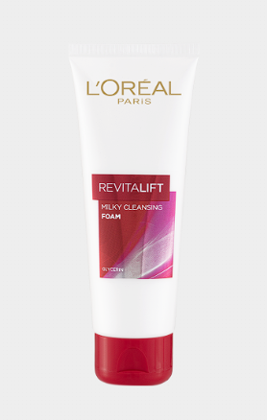

* **Serums**

**[Glycolic BrightAnti-Dark Spot Serum 30ml](https://www.lorealparis.com.ph/skin-care/glycolic-bright)**

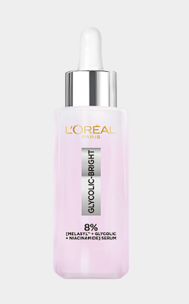

**[RevitaliftHyaluronic Acid Face Serum 30mL](https://www.lorealparis.com.ph/skin-care/revitalift)**

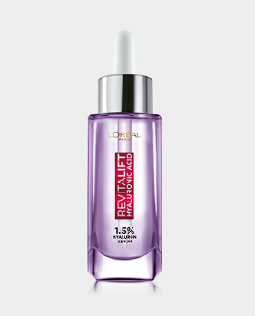

**[RevitaliftHyaluronic Acid Eye Serum 20ml](https://www.lorealparis.com.ph/skin-care/revitalift)**

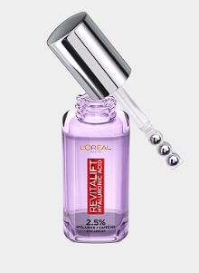

**[Glycolic BrightEye Serum 20mL](https://www.lorealparis.com.ph/skin-care/glycolic-bright)**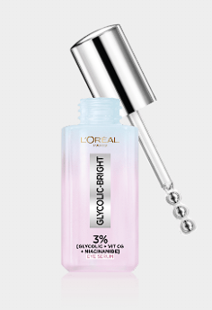

* **Moisturizers & Anti-Aging (Revitalift)**

**[Glycolic BrightGlowing Night Cream 50ml](https://www.lorealparis.com.ph/skin-care/glycolic-bright)**

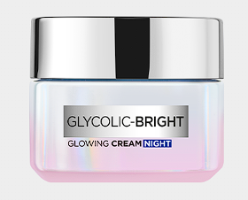

**[Revitalift Triple ActionTriple Action Day Cream 50ml](https://www.lorealparis.com.ph/skin-care/revitalift-triple-action)**

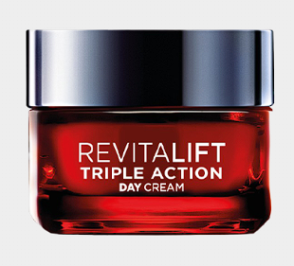

**[Revitalift Triple ActionTriple Action Night Cream 50ml](https://www.lorealparis.com.ph/skin-care/revitalift-triple-action)**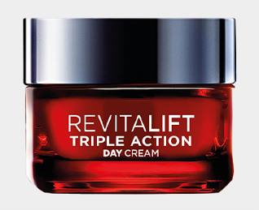

**[RevitaliftHyaluronic Acid Plumping Day Cream 50mL](https://www.lorealparis.com.ph/skin-care/revitalift)**

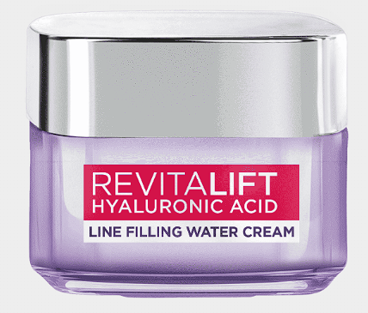

**[Glycolic BrightGlowing Day Cream SPF 17 50ml](https://www.lorealparis.com.ph/skin-care/glycolic-bright)**

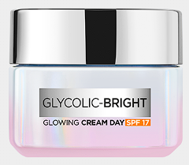

**[Revitalift Anti-Aging Night Cream 50mL](https://www.lorealparis.com.ph/skin-care/revitalift)**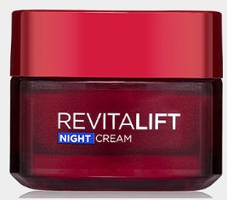

### **Haircare**

* **Shampoo & Conditioner**

**[Shampoo Ever Ever Pure Purple Shampoo](https://www.lorealparis.com.ph/hair-care/shampoo)**

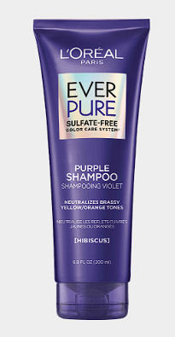

**[Conditioner Ever Ever Pure Purple Conditioner](https://www.lorealparis.com.ph/hair-care/conditioner)**

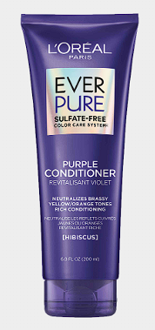

**[Shampoo Ever Strong Thickening Shampoo](https://www.lorealparis.com.ph/hair-care/shampoo)**

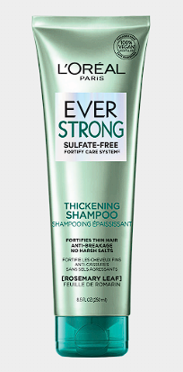

**[Conditioner Ever Strong Thickening Conditioner](https://www.lorealparis.com.ph/hair-care/conditioner)**

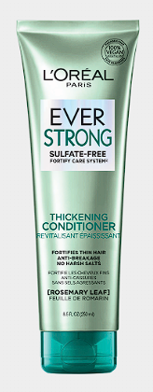

**[Shampoo Ever Pure Frizz-Defy Shampoo](https://www.lorealparis.com.ph/hair-care/shampoo)**

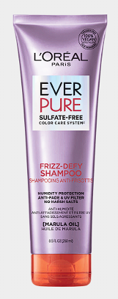

**[Shampoo Ever Pure Moisture Shampoo](https://www.lorealparis.com.ph/hair-care/shampoo)**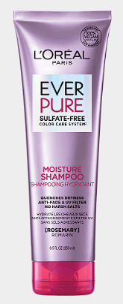

**[ConditionerEver Pure Moisture Conditioner](https://www.lorealparis.com.ph/hair-care/conditioner)**

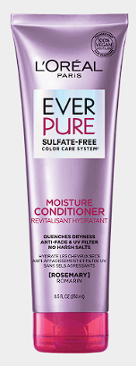

**[ConditionerEver Pure Frizz-Defy Conditioner](https://www.lorealparis.com.ph/hair-care/conditioner)**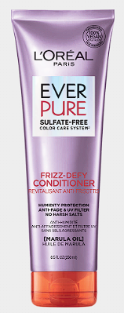

* **Hair Color**

**[Excellence Bleach Supreme](https://www.lorealparis.com.ph/hair-color/excellence)**

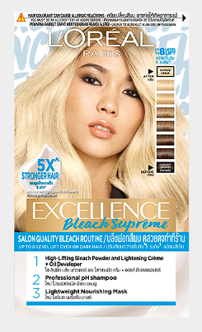

**[Excellence Crème Creme Triple Care Hair Color 3 Dark Brown](https://www.lorealparis.com.ph/hair-color/excellence)**

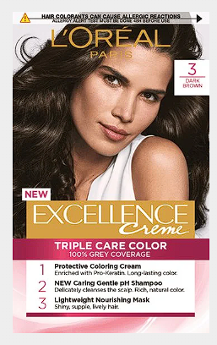

**[ExcellenceAsh Supreme Ash Supreme Hair Color 6.1 Brunette Ash](https://www.lorealparis.com.ph/hair-color/excellence)**

**[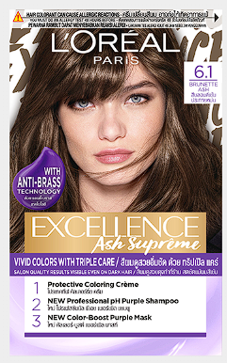](https://www.lorealparis.com.ph/hair-color/excellence)**

**[ExcellenceFashion Fashion Hair Color 5.13 Espresso Ash Brown](https://www.lorealparis.com.ph/hair-color/excellence)**

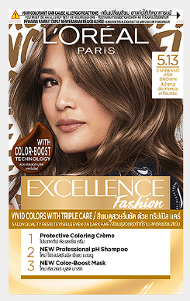

**OLAY**

* **Cleansers & Makeup Removers**

**Olay Gentle Cleansing Melts**

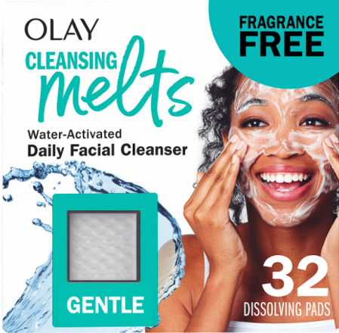

**Olay Cleansing Melts + Vitamin C**

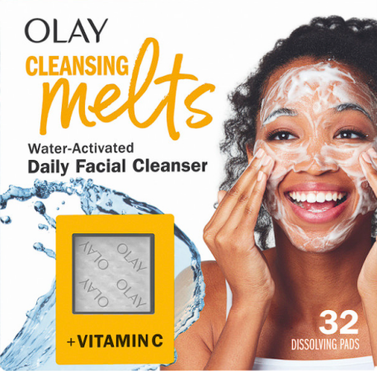

**Olay Cleansing Melts + Hyaluronic**

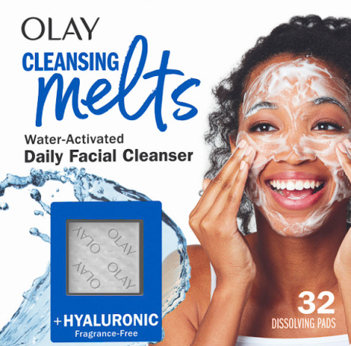

**Olay Cleansing Melts + Retinol**

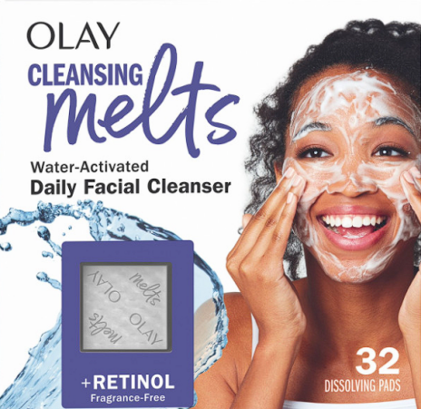

**Olay Gentle Cleansing Balm**

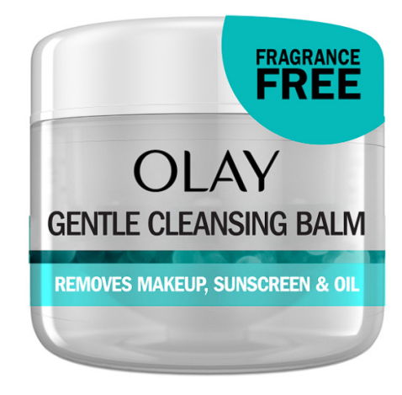

**Olay Refreshing Gel Cleanser with Hyaluronic**

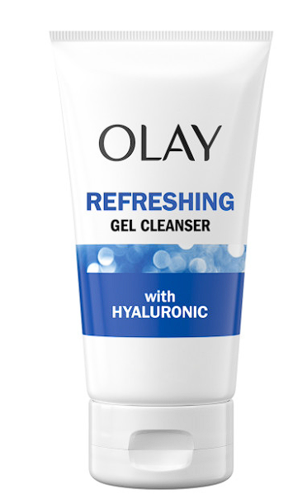

**Olay Brightening Exfoliating Cleanser with Vitamin C**

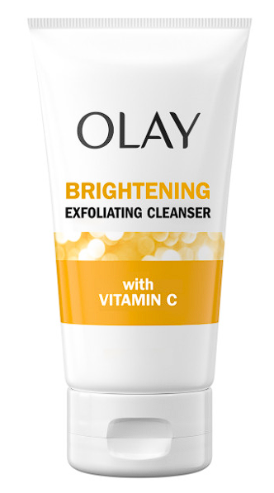

**Olay Regenerating Cream Cleanser with Vitamin E**

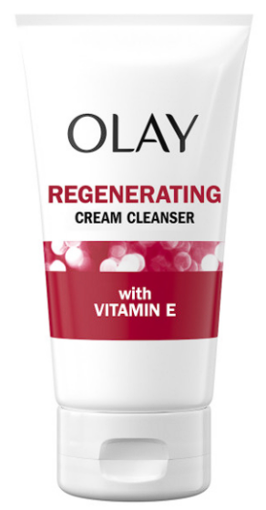

**Olay Balancing Cream Cleanser with Collagen Peptide**

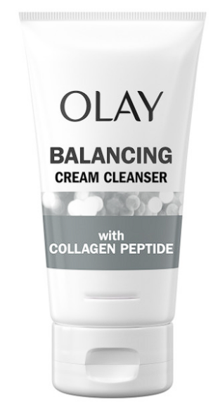

**Olay Renewing Exfoliating Cleanser with Retinol**

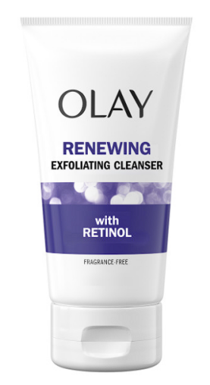

* **Sensitive Skins**

**Complete Lotion Moisturizer Sensitive SPF 30**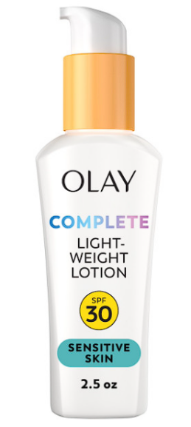

**Olay Complete + Hydrating Lotion Sensitive**

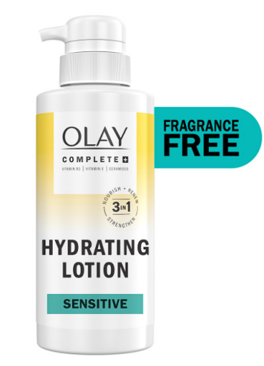

**Complete Lotion Moisturizer Sensitive with Sunscreen SPF 15 6oz**

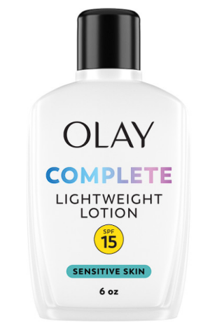

**Complete Lotion Moisturizer Sensitive SPF 15 4oz**

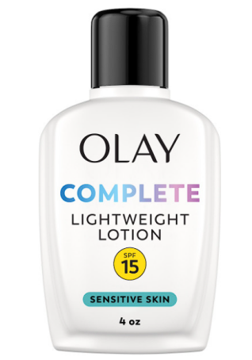

**Olay Complete + Rich Moisturizing Cream Sensitive**

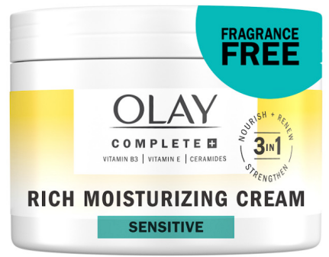

* **Moisturizers**

**Regenerist Micro-Sculpting Cream Moisturizer**

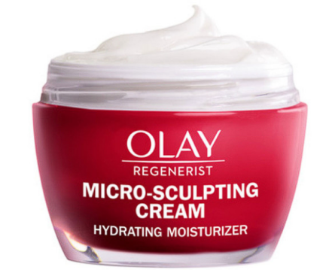

**Olay Retinol24 Night Moisturizer**

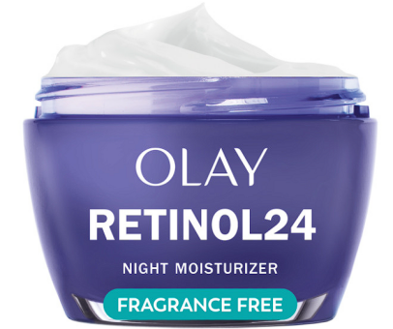

**Olay Vitamin C Lightweight Hydrating Moisturizer**

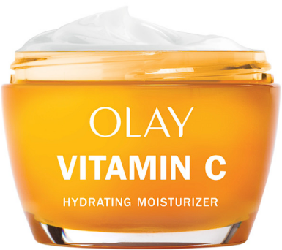

**Olay Hyaluronic Ultralight Gel**

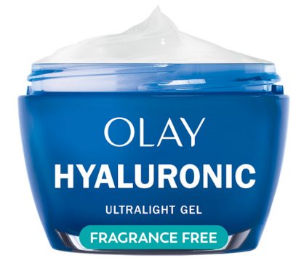

**Olay Niacinamide Hydrating Cream**

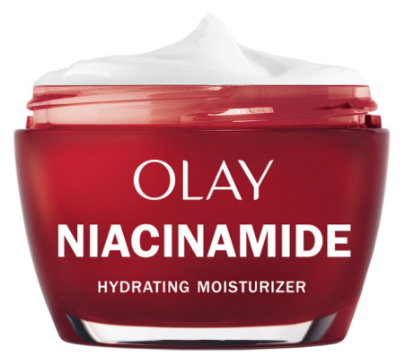

**Olay Retinol 24 MAX Night Moisturizer**

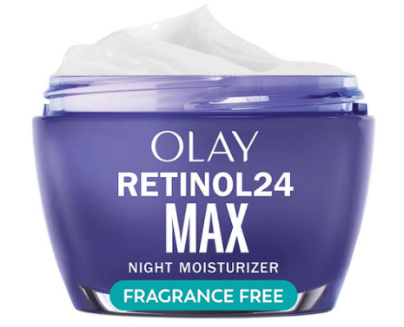

**Olay Collagen Peptide MAX Moisturizing Cream**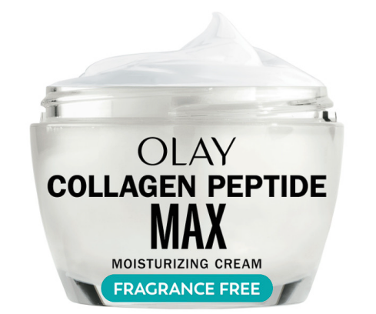

* **Serum & Treatments**

**Super Serum**

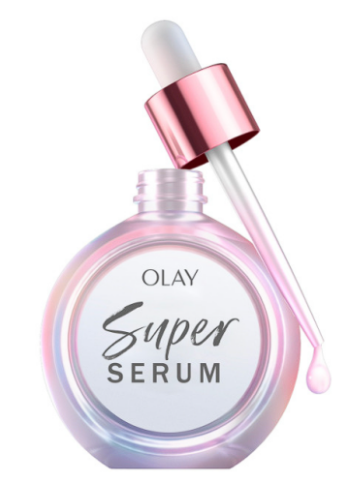

**Olay Super Eyes Daily Eye Serum**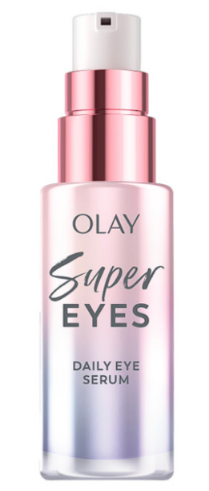

**Super Serum Night Repair**

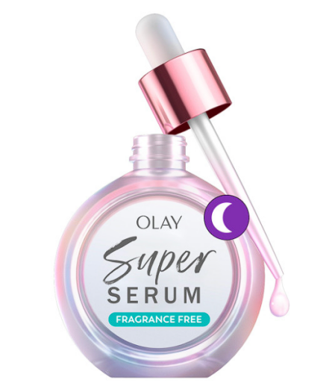

**Olay Retinol 24 Night Smoothing Serum**

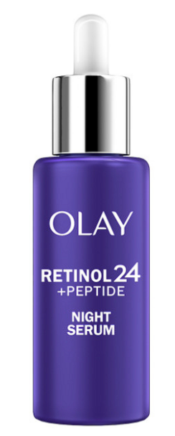

**Olay Vitamin C Brightening Serum**

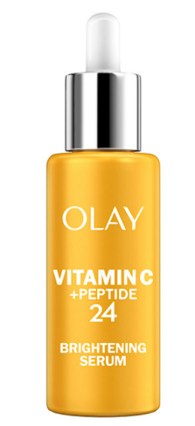

**Olay Collagen Peptide MAX Visibly Firming Serum**

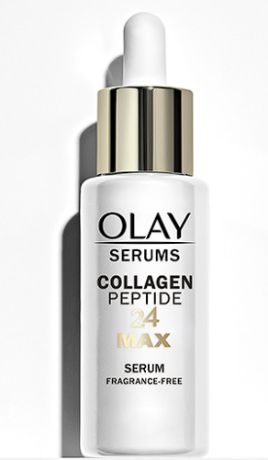

**Olay Retinol 24 MAX Night Smoothing Serum**

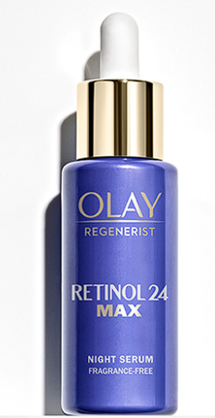

**Olay Niacinamide MAX Wrinkle Reducing Serum**

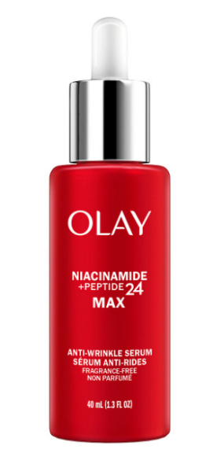

**Regenerist Micro-Sculpting Serum Original**

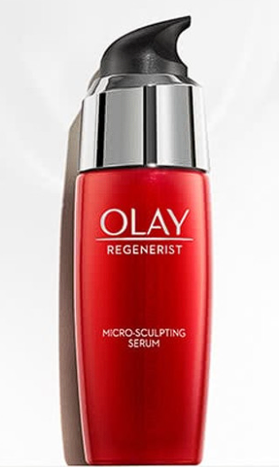

* **SPF**

**Olay Hyaluronic Hydrating Facial Moisturizer with Sunscreen SPF 30**

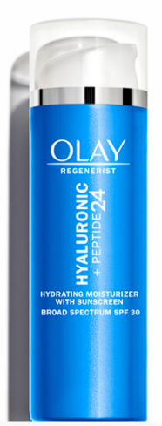

**Regenerist Micro-Sculpting Cream Moisturizer**

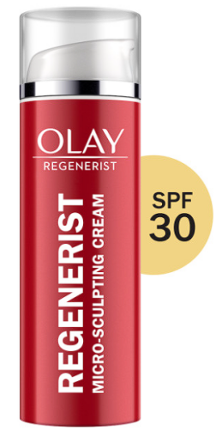

**Regenerist Whip SPF 25**

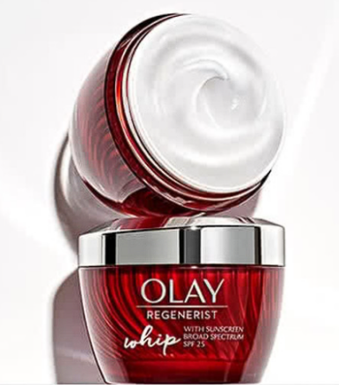

**Prime + Protect Facial Sunscreen SPF 35**

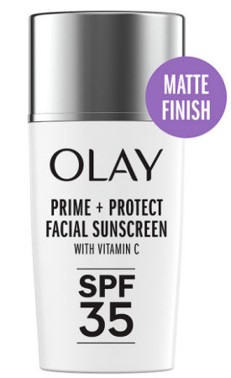

**Olay Vitamin C Brightening Facial Moisturizer with Sunscreen SPF 30**

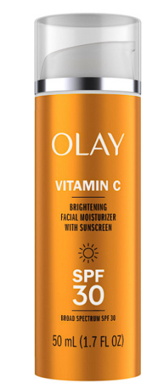

**Olay Invisible Sunscreen SPF 35**

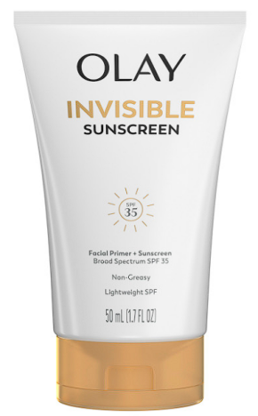

* **Body Care**

**Olay Limited Edition Serum Body Wash, Couldn't Be Lovelier, 20 fl oz, Glinda's Edition Hydrating Body Wash**

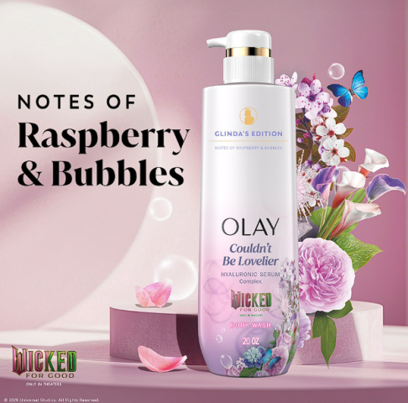

**Olay Limited Edition Serum Body Wash, Wickedly Wonderful, 20 fl oz, Elphaba's Edition Hydrating Body Wash**

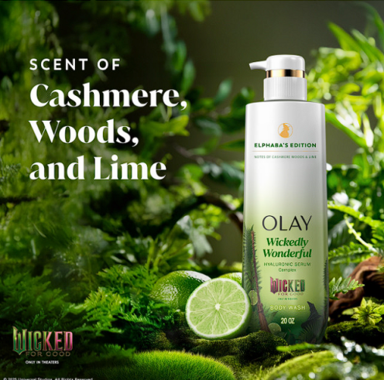

**Olay Intensely Hydrating Body Wash, Strawberry**

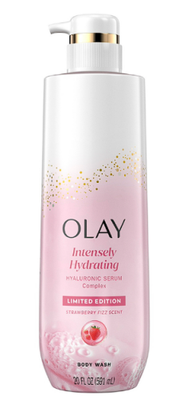

**Olay Intensely Hydrating Body Wash, Mandarin**

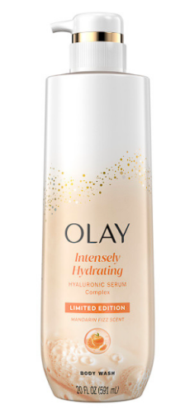

**Olay Super Serum Body Wash for Extra Dry Skin**

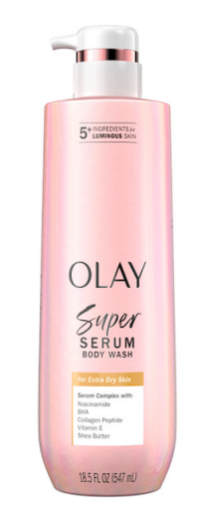

**Olay Super Serum Body Wash, Normal Skin**

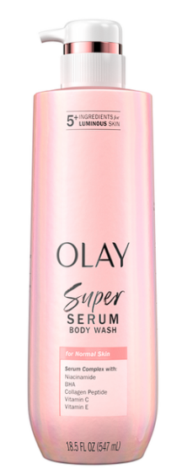

**Olay Super Serum Body Wash for Rough & Bumpy Skin**

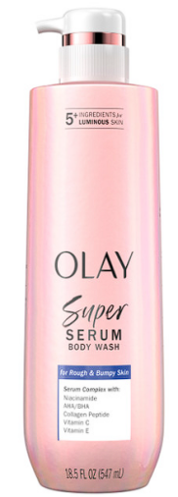

# **Olay Fresh Radiance Body Wash**

# 

**Olay Ultra Moisture Hydrating Body Wash**

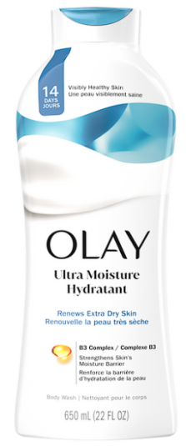

**Olay Day & Night Restoring Hydrating Body Lotion**

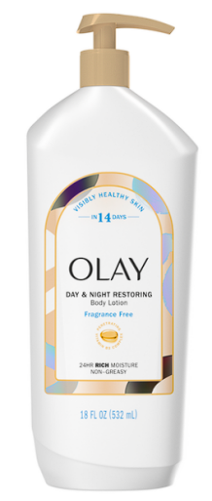

**Olay Ultra Rich Moisture Hydrating Body Lotion**

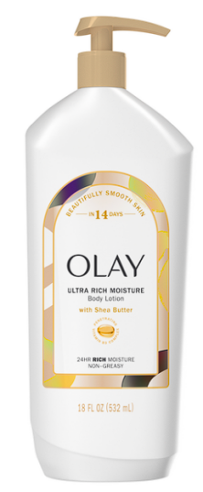

**Olay Soothing Dryness Relief Hydrating Body Lotion**

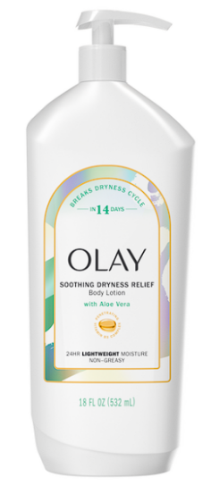

**SEPHORA**

**Makeup**

* **Foundations**

Best Skin Ever Perfect Natural Finish Longwear Foundation **• 25ml**

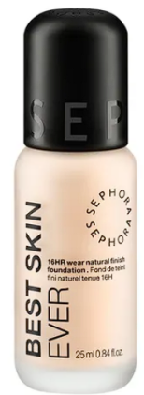

Care Foundation **• 30ml**

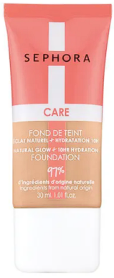

Original Best Skin Ever Perfect Natural Finish Longwear Foundation • 25ml

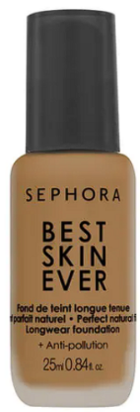

Reveal the Real Soft Radiant Skin Tint • 30 ml

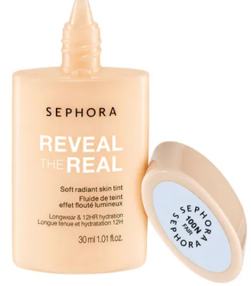

Best Skin Ever Glow 12HR Moisturizing Liquid Foundation • 25ml

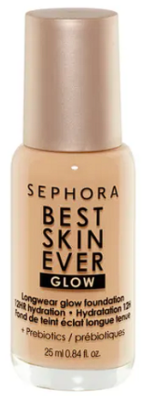

Glow Perfection Foundation • 20ml

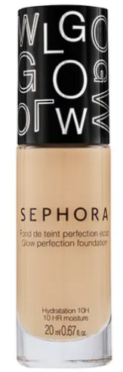

Matte Perfection Stick Foundation & Concealer • 11.6g

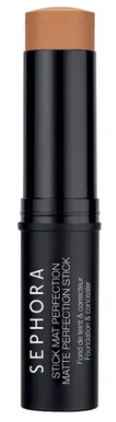

Matte Perfection Liquid Foundation • 30m

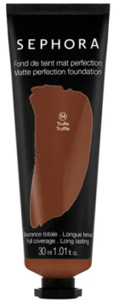

* **Concealers & Correctors**

Best Skin Ever High Coverage Concealer **• 5ml**

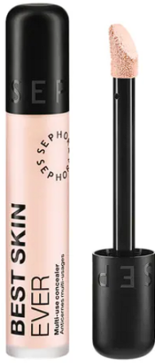

Best Skin Ever Color Corrector **• 5ml**

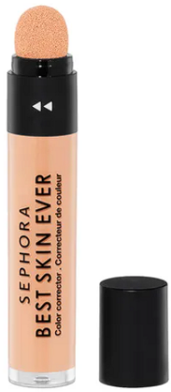

Original Best Skin Ever High Coverage Concealer **• 5ml**

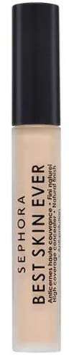

**Best Skin Ever Glow Multi-Purpose Concealer**

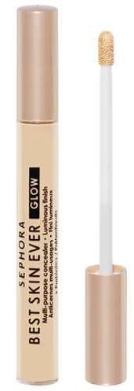

Bright Future Smoothing & Brightening Concealer **• 2.5ml**

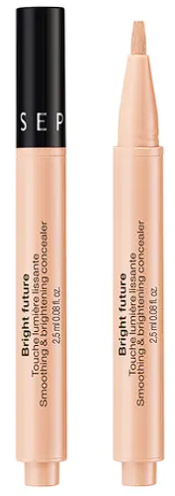

Color Corrector **• 3.4ml**

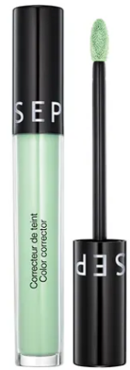

Clear & Cover Corrector **• 4.2g**

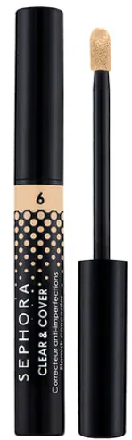

**High Coverage Concealer**

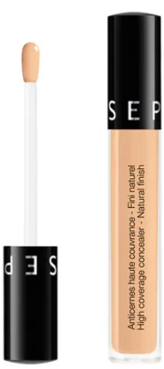

Matte Perfection Stick Foundation & Concealer **• 11.6g**

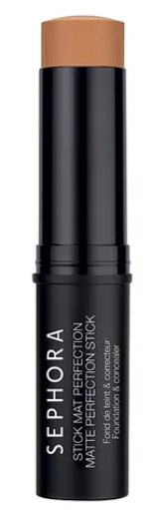

* **Blushes**

Color Twister Lip & Cheek Color Changing Oil-in-Stick **• 8.50g**

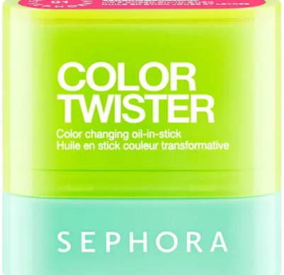

Blush & Go **• 7ml**

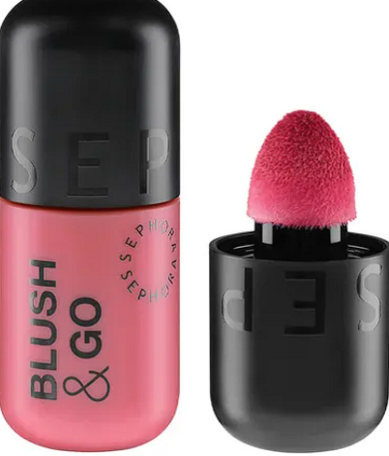

All-In-One Cream Color Blush **• 3.5g**

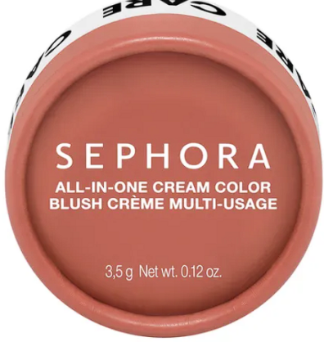

Colorful Blush **• 3.50g**

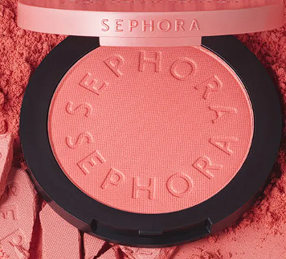

Blush Blush Blush Palette **• 10g**

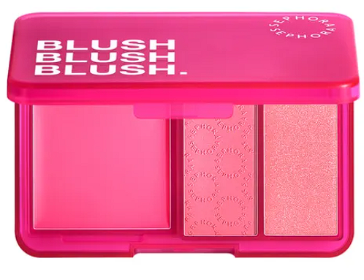

**Lip & Cheek Ornament Balm (Holiday Limited Edition)**

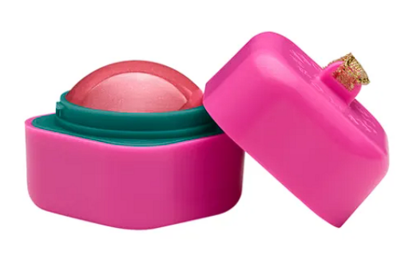

* **Bronzer**

Matte Bronzer **• 8g**

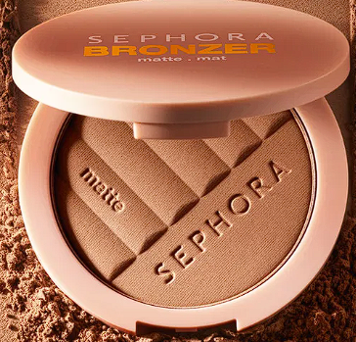

Make It Bronze **• 5.5g**

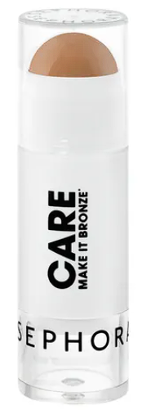

**Instant Bronzing Drops**

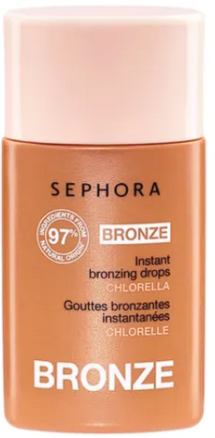

Original Matte Bronzing Powder **• 8g**

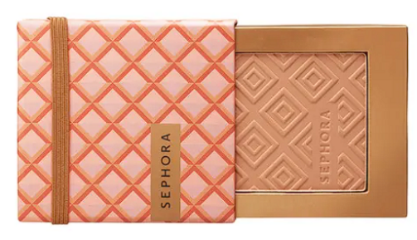

**Bronzing Powder**

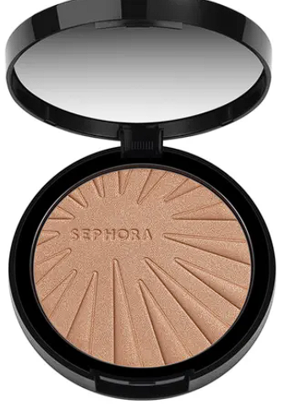

Sun Disk Bronzing Powder **• 30g**

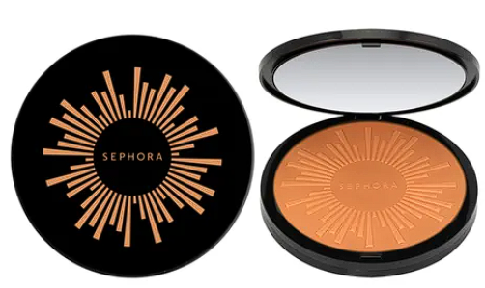

* **Powders**

Blur It Loose Setting Powder **• 7.5g**

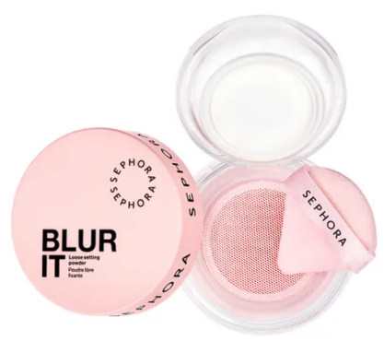

12HR Mattifying Finishing Powder **• 10g**

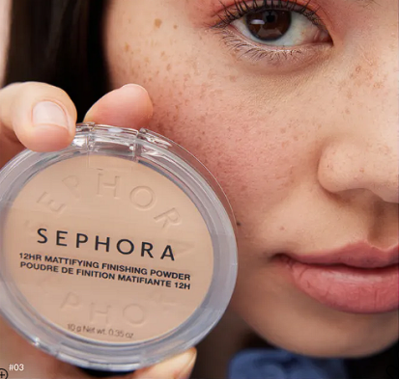

**12HR Setting & Mattifying Powder**

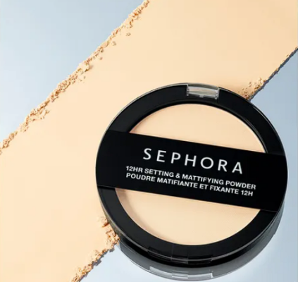

Care Mineral Compact Powder Foundation - Matte Finish & Soothing Effect **• 10g**

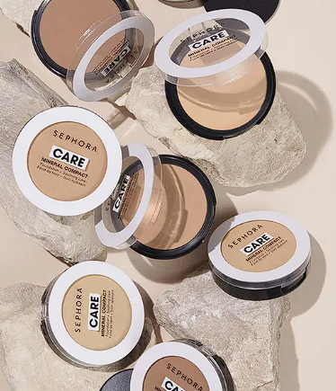

Smoothing & Brightening Powder • 8g

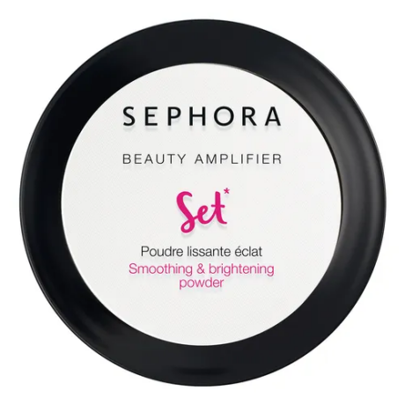

Smoothing & Setting Powder

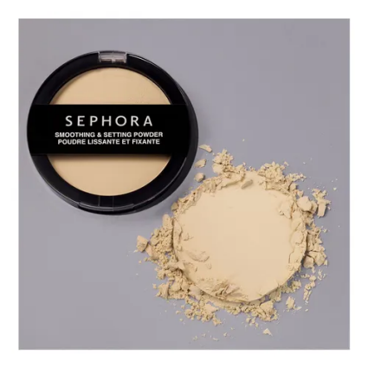

Original Translucent Loose Setting Powder

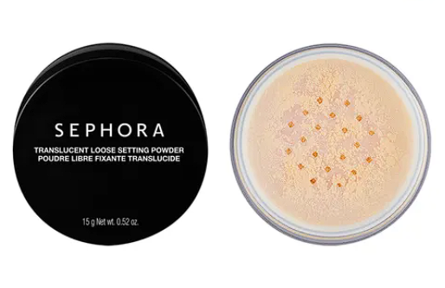

* **Lips**

Totally Juicy Lip Tint • 5.50ml

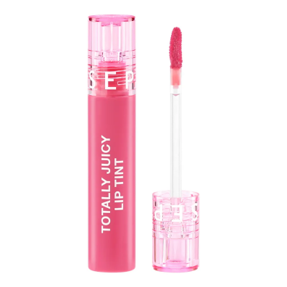

Soft Matte and Easy Lip Stain • 4.5ml

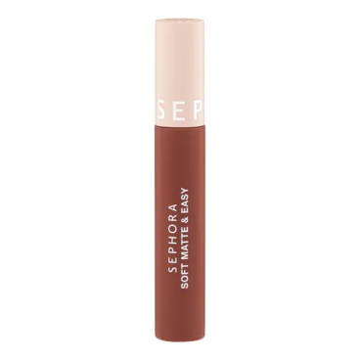

Outrageous Plump Extreme • 6ml

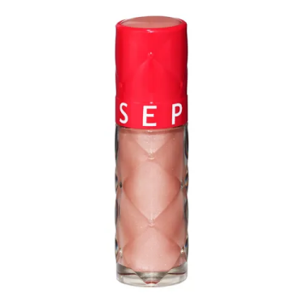

Rouge Is Not My Name Matte Lipstick • 3.5g

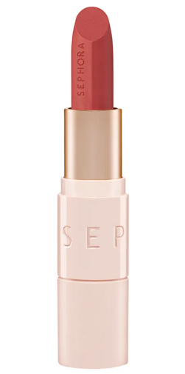

Best Lip Combo Duo (Holiday Limited Edition)

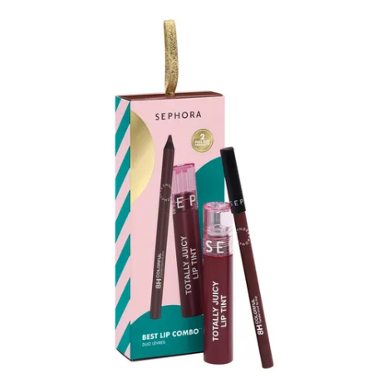

Glossed Set (Holiday Limited Edition)

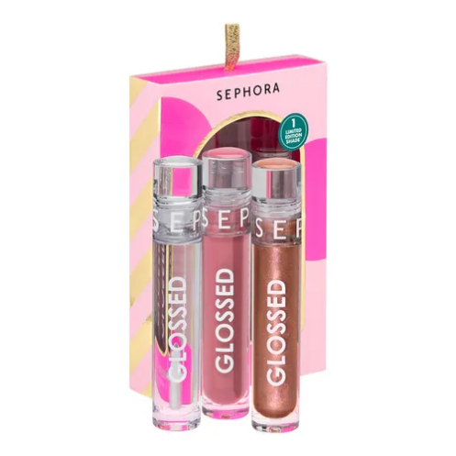

Glossed Vinyl Lip Gloss • 5ml

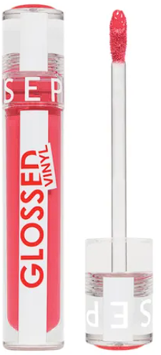

Lip Balm

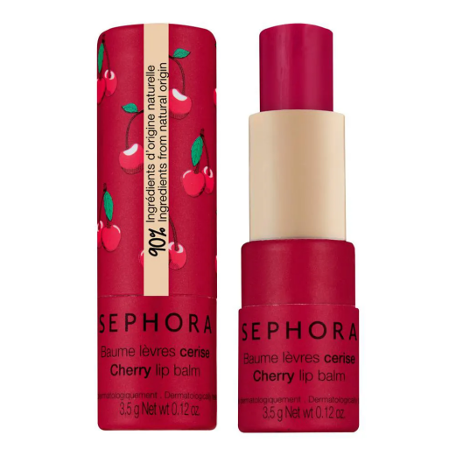

Moving Lights Cream Lip Stain Set (Holiday Limited Edition)

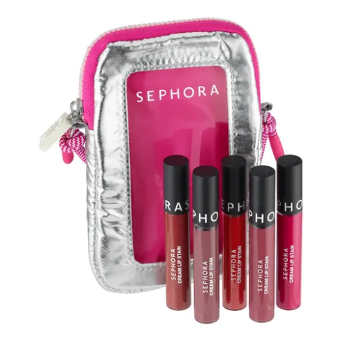

Lip Stain Liner

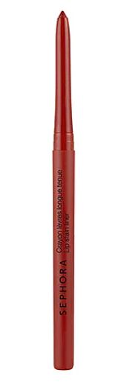

**SKIN CARE**

* **Facial Cleanser**

Mini Cleansing Set (Holiday Limited Edition)

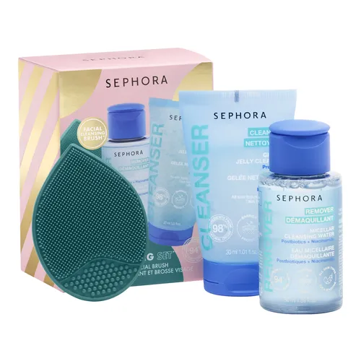

Glow Brightening Cleansing Powder

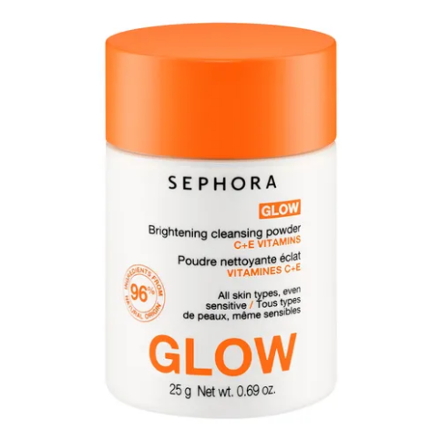

Comfort Cleansing Oil

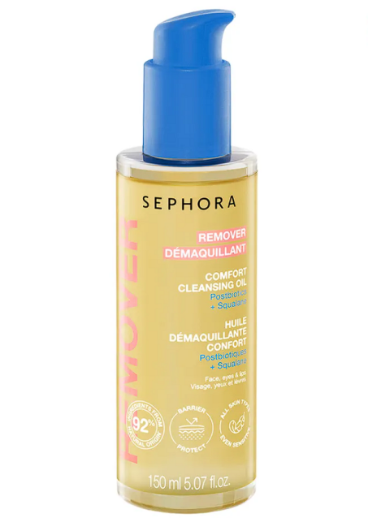

Micellar Cleansing Milk

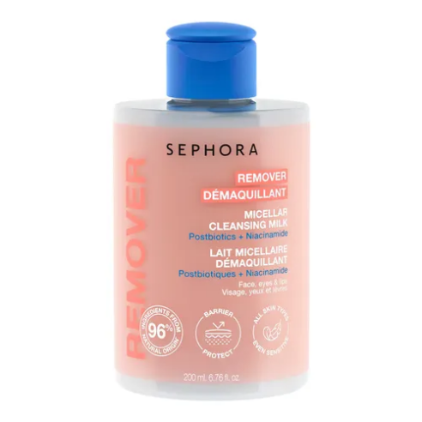

Cleansing & Soothing Micellar Gel

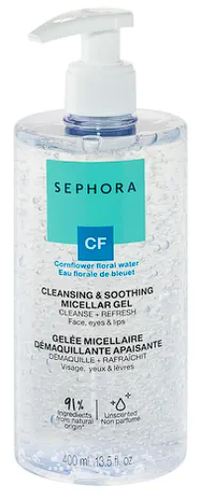

* **Scrub & Exfoliator**

Bright Skin Exfoliating Scrub • 50ml

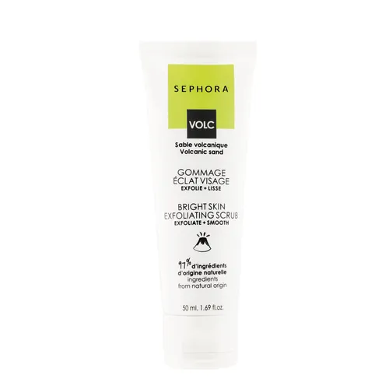

Exfoliating Face Disc

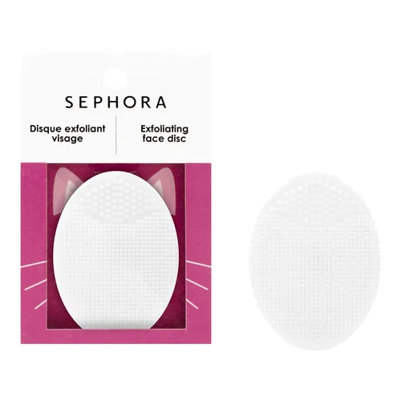

Double Exfoliation Face Foaming Scrub

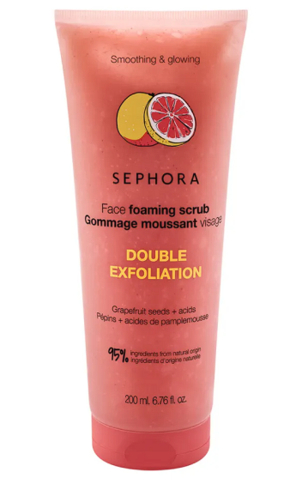

Face Konjac Sponge

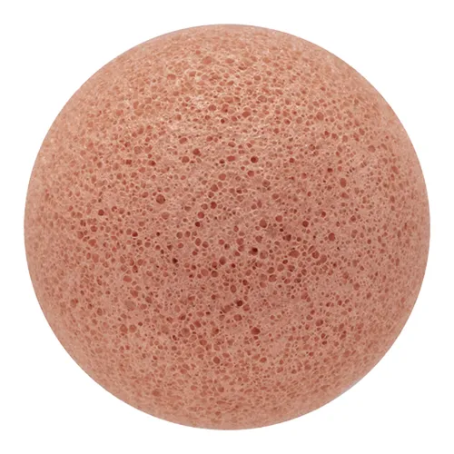

* **Toner**

Super Glow Toner With Vitamins C + E

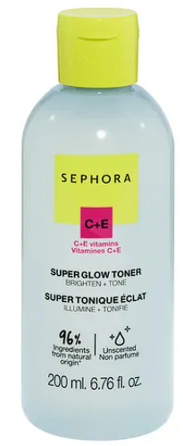

Clarifying Toner With 5% Niacinamide & Zinc

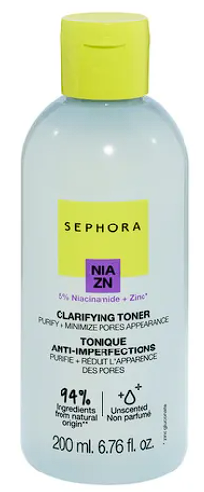

Vitamin Tonic Lotion • 100ml

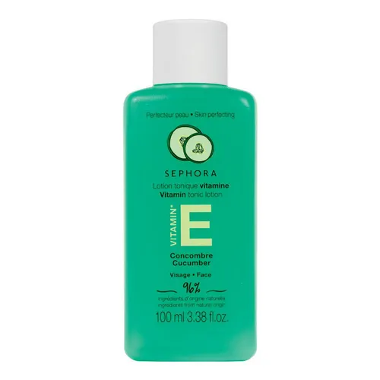

Gentle PH Balancing Toner

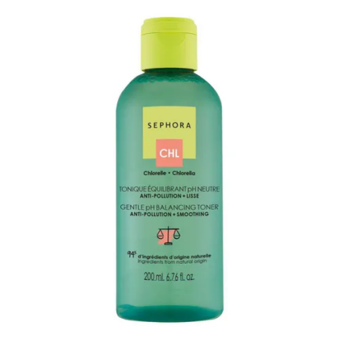

* **Masks**

Fiber Face Masks

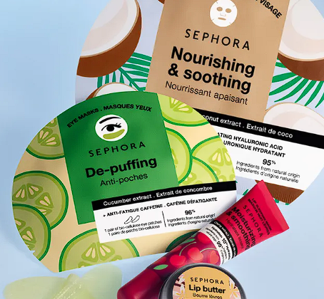

Foot Masks

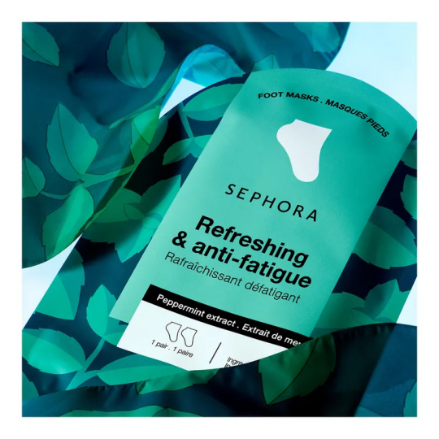

Booster Face Masks • 1piece

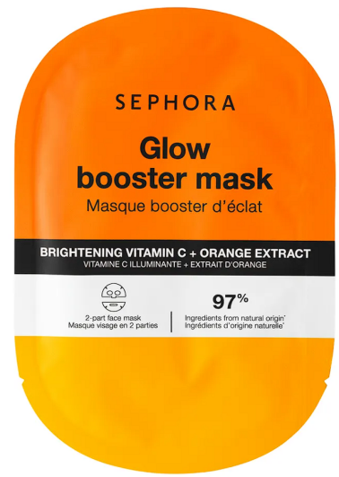

Overnight Dose Mask • 30ml

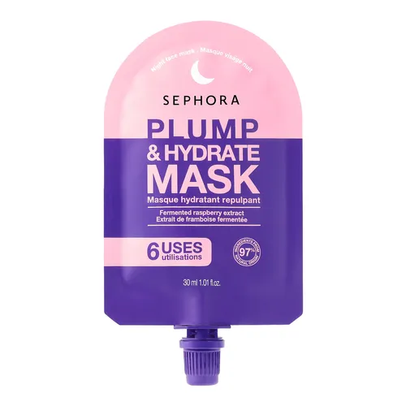

Silicone Reusable Eye Patches

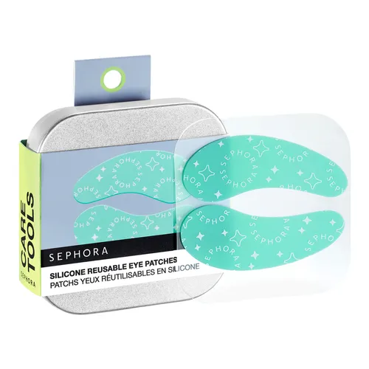

* **Face Oil**

Lift & Firm Recovery Firming Night Oil

# 

Smoothing Beard Oil

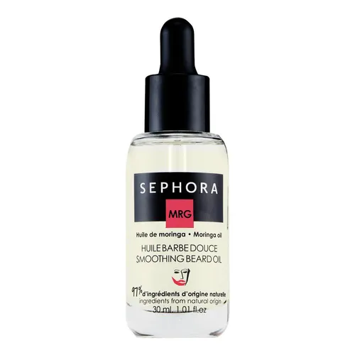

* **Lip Care**

Oil Infusion Hydrating Lip Oil • 3ml

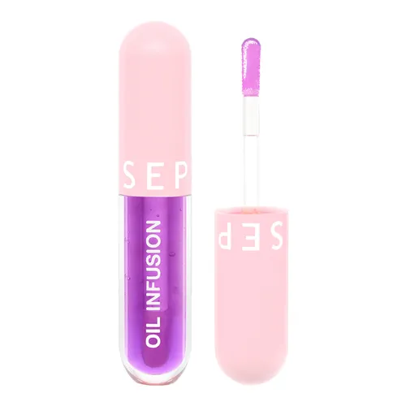

Moisturizing Lip Balm - 8HR Hydrating Treatment • 3.5g

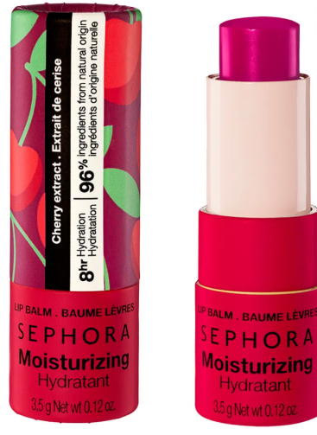

Nourishing Lip Butter • 10g

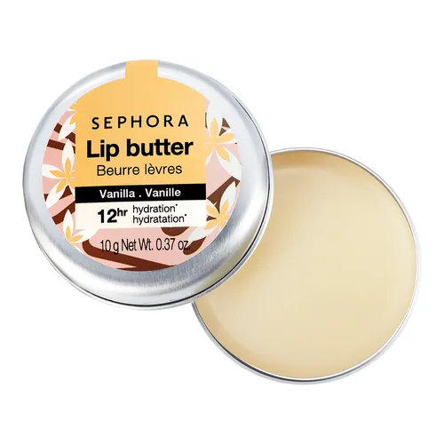

Original Lip Scrubs • 3.5g

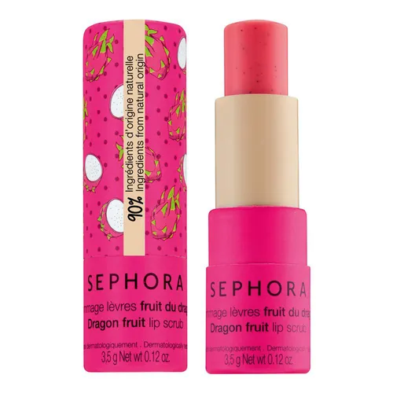

Shea Lip Mask

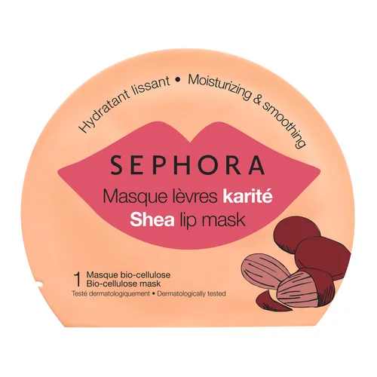

**TOOLS**

* **Brushes**

Starter Brushes Set

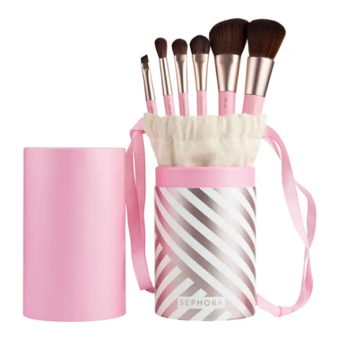

Pro 8-Piece Face & Eyes Brush Set (Holiday Limited Edition)

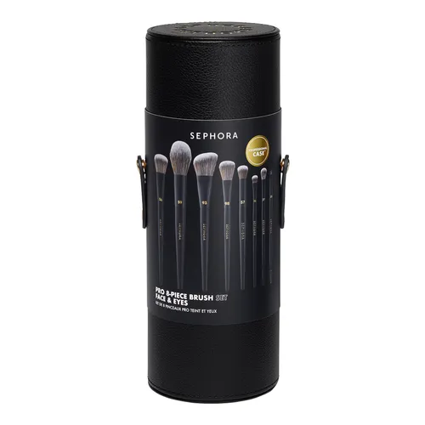

Essential Eye Brush Kit

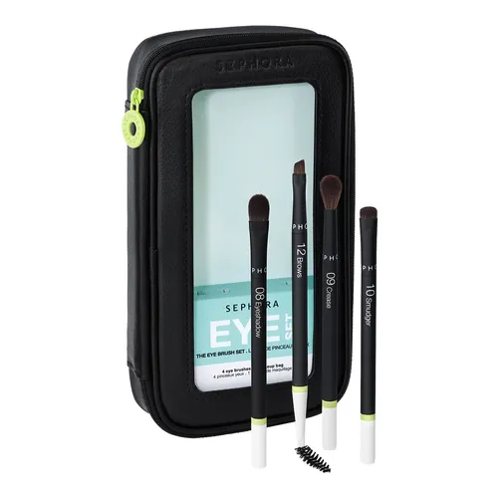

Essential Total Brush Set

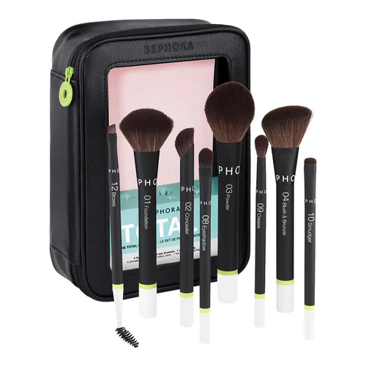

Set of 3 To-Go Essential Brushes Set (Holiday Limited Edition)

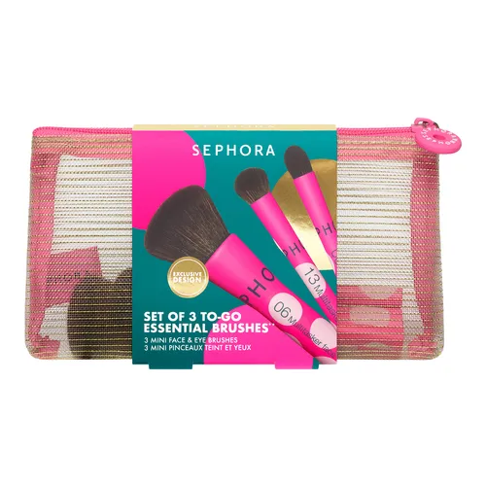

Glitter Brush Set - 4 Eye Brushes

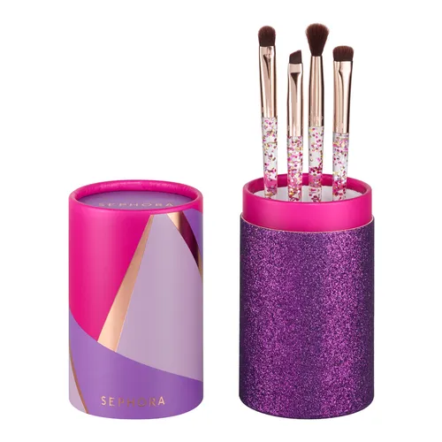

* **Sponges**

Pillow Dream Face Sponge Set

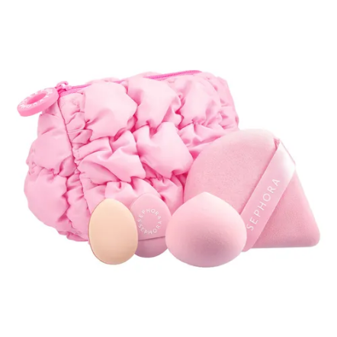

**Flawless Complexion Angled Sponge**

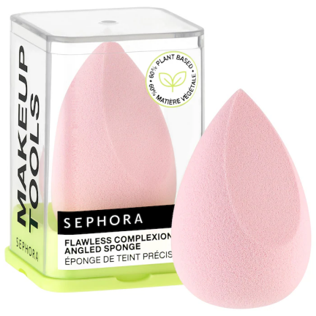

**ORIGINAL Beautyblender® Makeup Sponge**

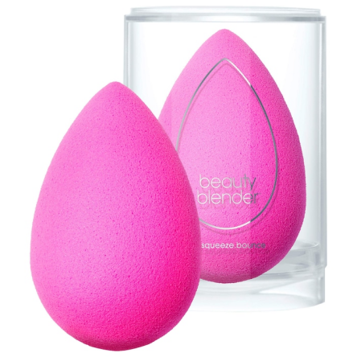

**Flawless Complexion Sponge**

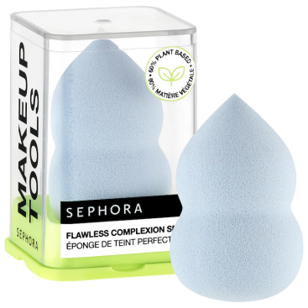

**Tap That Puff Makeup Sponge**

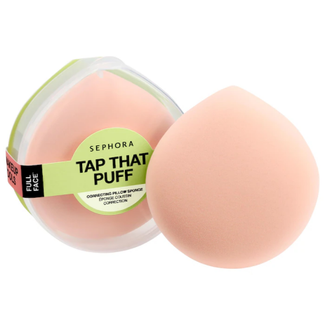

**Perfect Sponges Set**

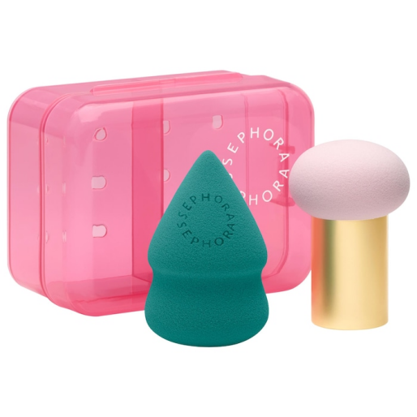

**Maybelline**

* **Foundations**

**Super Stay® Lumi-Matte Foundation makeup**

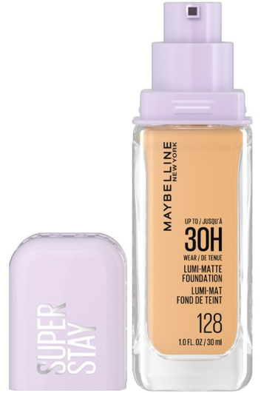

**Fit Me® Matte + Poreless Foundation Makeup**

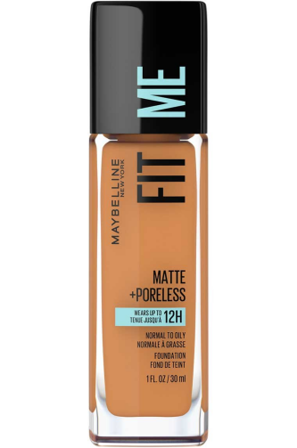

**Lifter Plump & Glow Foundation**

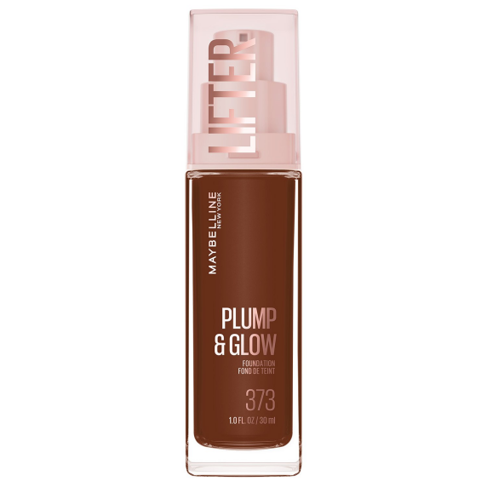

**Super Stay® Up to 24HR Long-Lasting Skin Tint with Vitamin C**

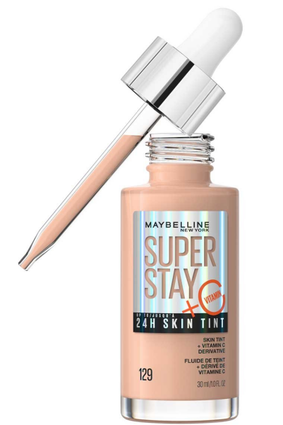

**Instant Age Rewind Perfector® 4-In-1 Glow Makeup®**

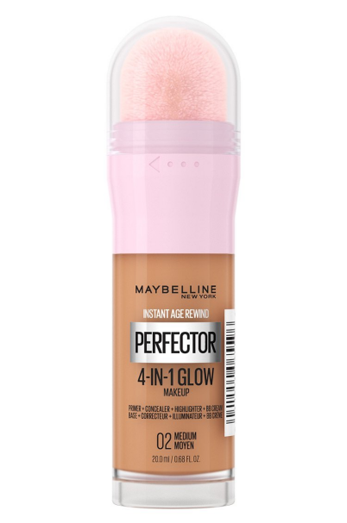

**Dream Radiant Liquid® Hydrating Foundation**

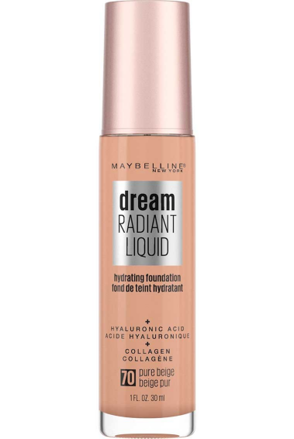

**Dream Urban Cover® Flawless Coverage Foundation Makeup, Spf 50**

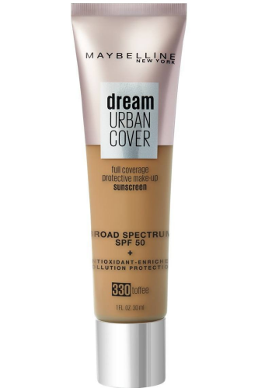

**Fit Me® Dewy + Smooth Foundation Makeup**

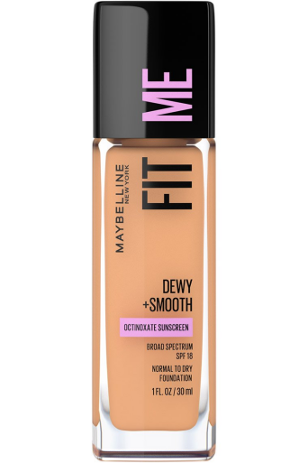

* **Concealer**

**Instant Age Rewind® Eraser Multi-Use Concealer**

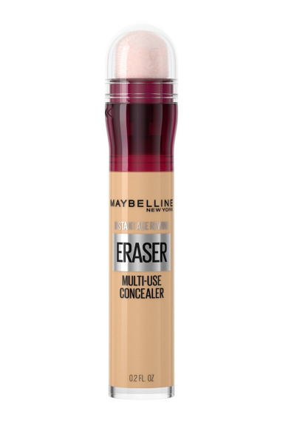

**Lifter Serum Concealer**

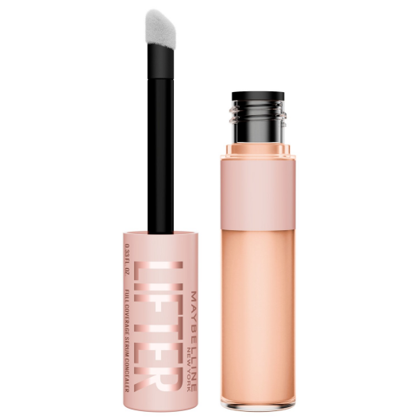

**Fit Me® Concealer Face Makeup**

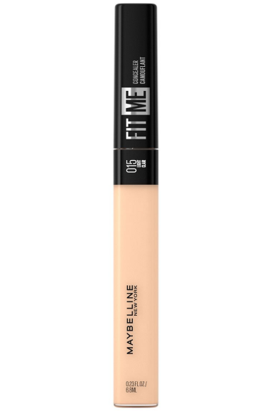

**Super Stay® Longwear Liquid Concealer Up To 30Hr Wear**

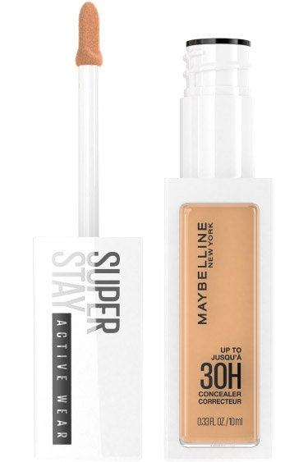

* **Powders**

**Fit Me® Matte + Poreless Powder Foundation Makeup**

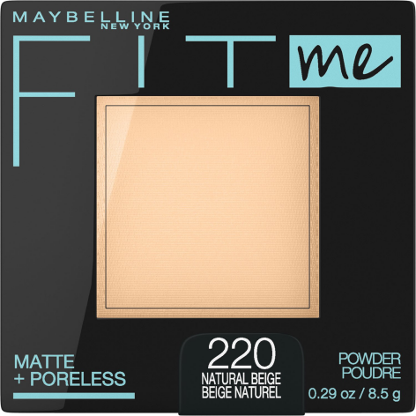

**Super Stay® Up To 24Hr Hybrid Powder-Foundation**

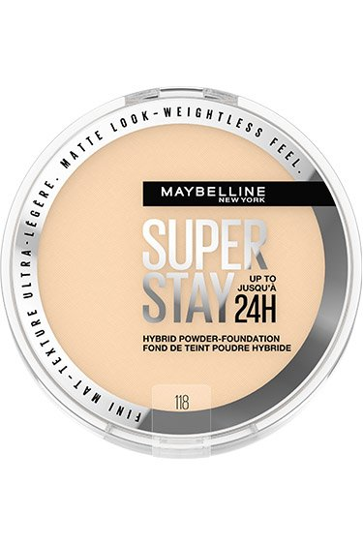

**Lasting Fix® Banana Powder Loose Setting Powder Makeup**

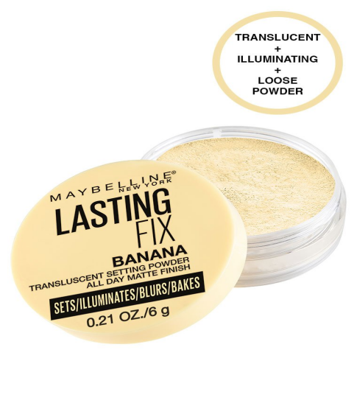

**Fit Me® Loose Finishing Powder Face Makeup**

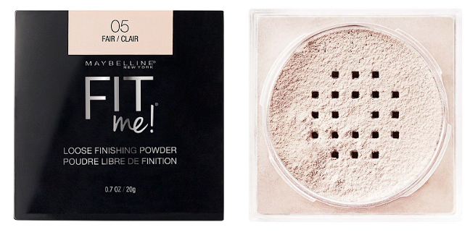

* **Blushes**

**Cloudtopia Cheek & Lip Mousse Blush**

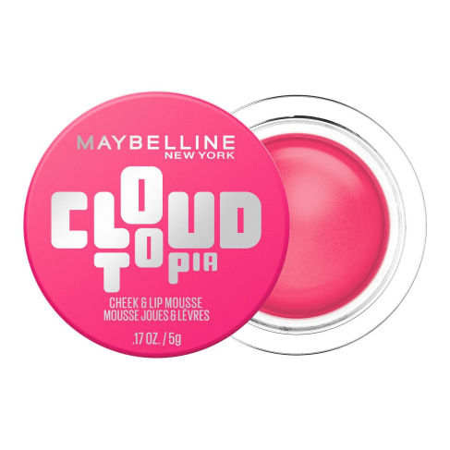

**Sunkisser Multi-use Liquid Blush and Bronzer**

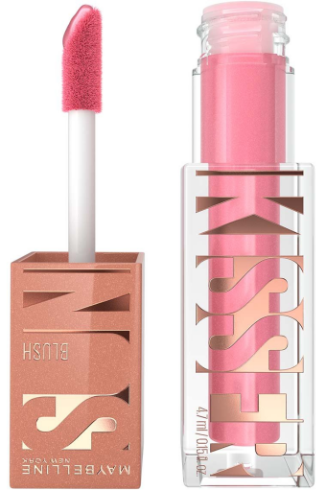

**Cheek Heat® Gel-Cream Blush, Face Makeup**

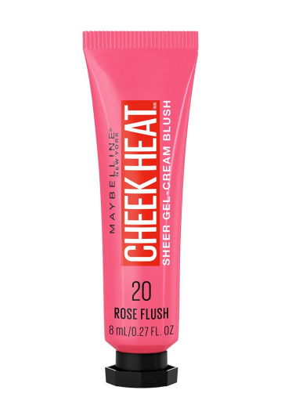

**Fit Me® Blush Face Makeup**

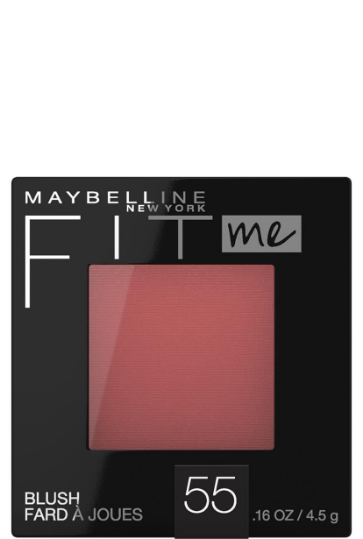

* **Highlighters**

**Facestudio® Master Holographic® Prismatic Highlighter**

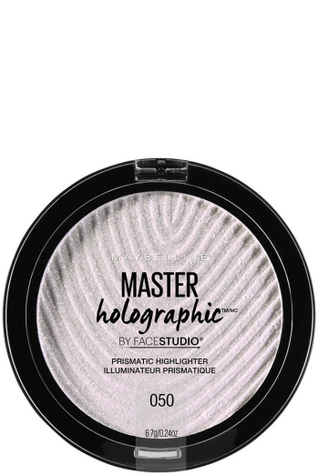

**Facestudio® Master Chrome® Metallic Highlighter Makeup**

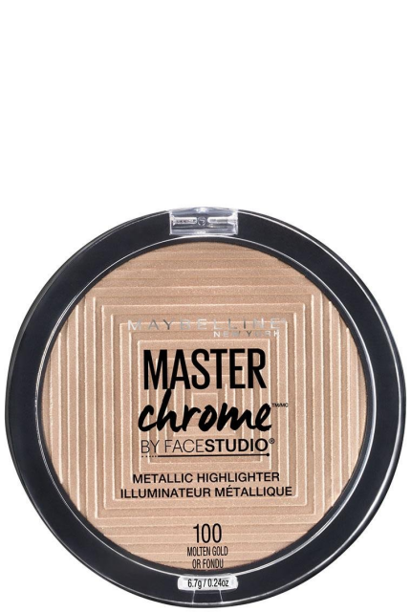

**Facestudio® Master Strobing Stick™ Illuminating Highlighter**

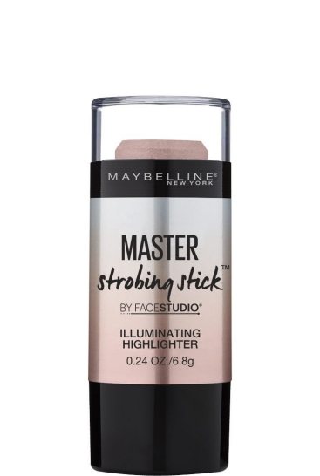

* **BB Creams**

**Dream BB Pure® BB Cream**

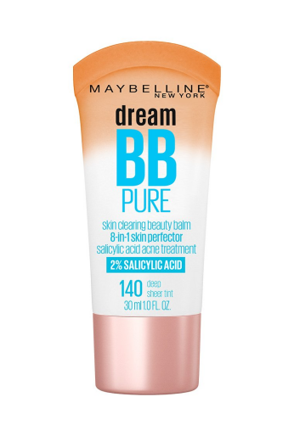

**Dream BB Fresh® BB Cream**

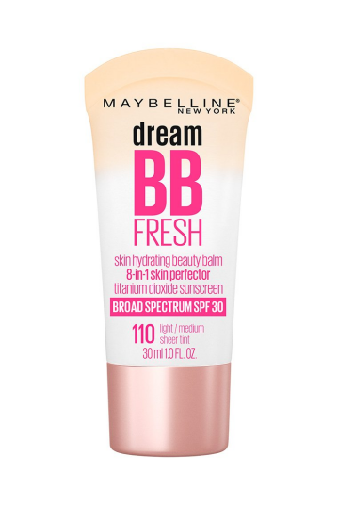

* **Primers & Setting Sprays**

**PORELESS JELLY™ UP TO 24HR HYDRATING BLUR PRIMER**

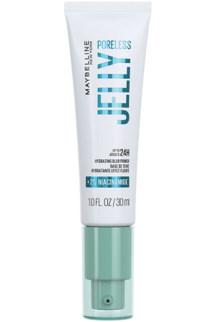

**GRIPPY SERUM™ Up To 24HR Hydrating Grip Primer**

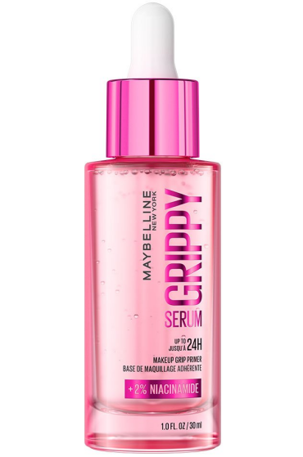

**Fit Me® Matte + Poreless Primer Mattifying Face Primer**

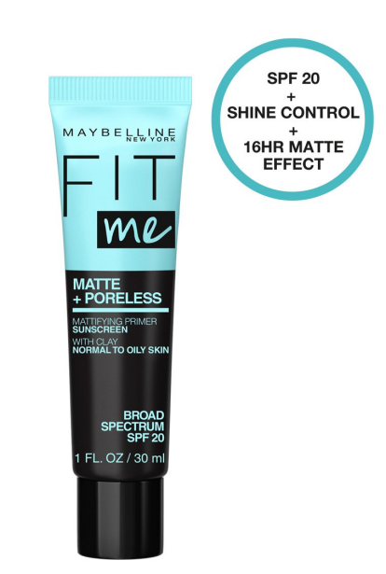

**Facestudio® Glass Spray Glass-Skin Makeup Finishing Spray**

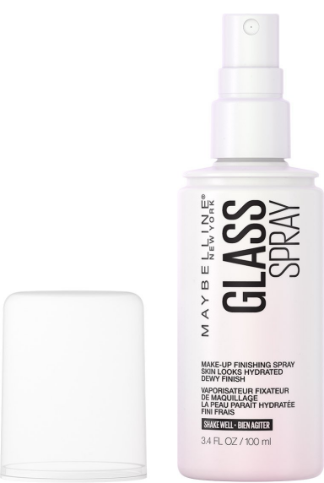

**Facestudio® Lasting Fix Makeup Setting Spray, Matte Finish**

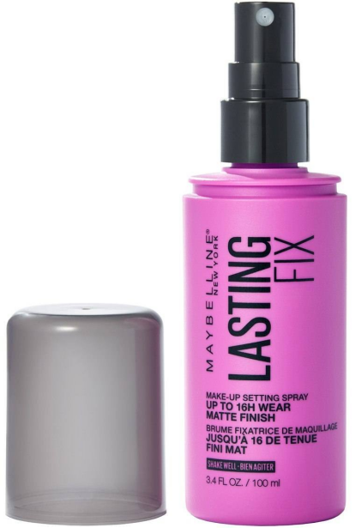

**Facestudio® Master Blur Stick Primer Makeup**

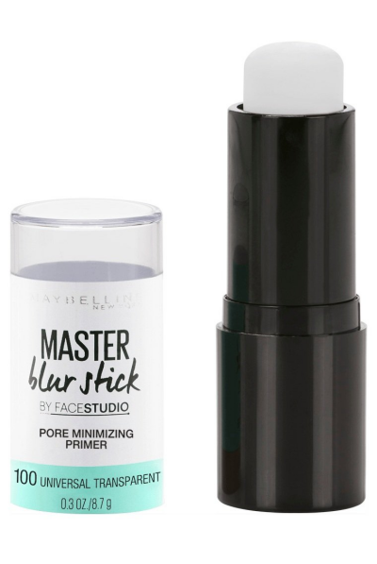

Facestudio® Master Prime Primer Makeup

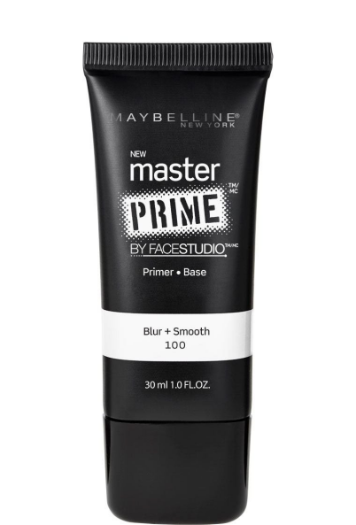

Baby Skin® Instant Pore Eraser®

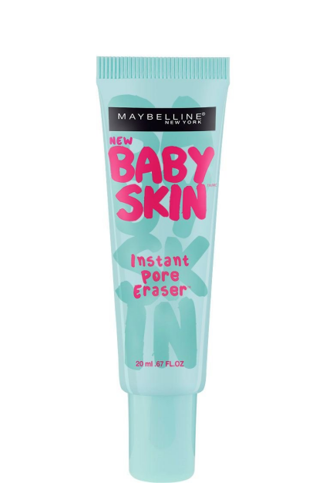

* **Eye Makeup**
* **Mascara**

**Lash Sensational Body Full Volume Lifting Waterproof Mascara​**

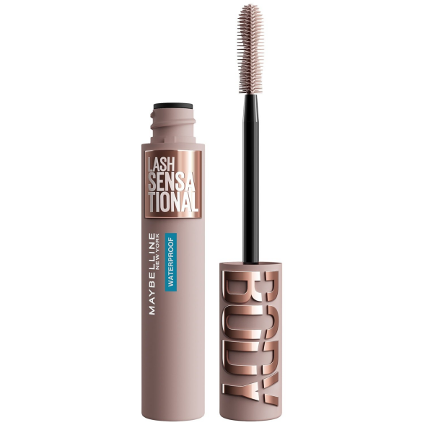

**Lash Sensational Body Full Volume Lifting Washable Mascara​**

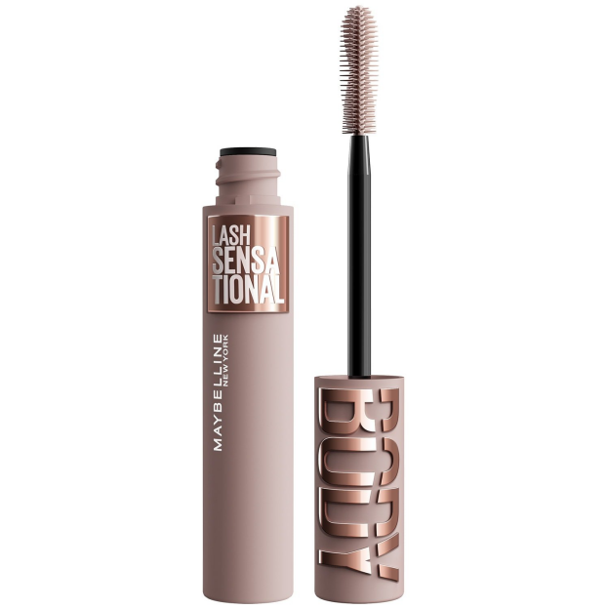

**Lash Sensational Sky High® Washable Lengthening & Volumizing Mascara**

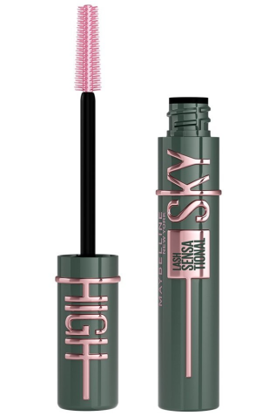

**Lash Sensational Sky High® Washable Lengthening & Volumizing Mascara**

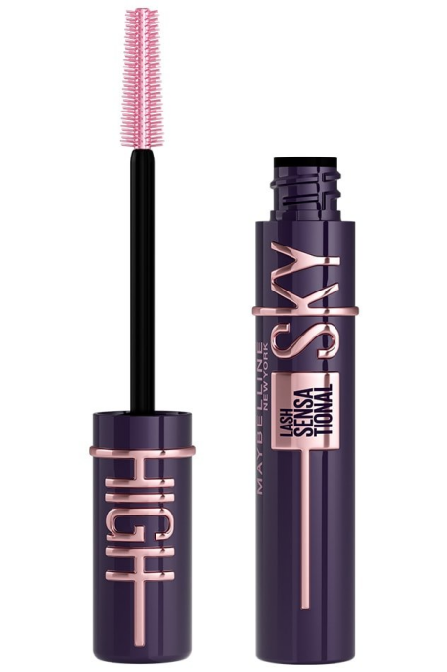

**Colossal Bubble™ Washable Mascara**

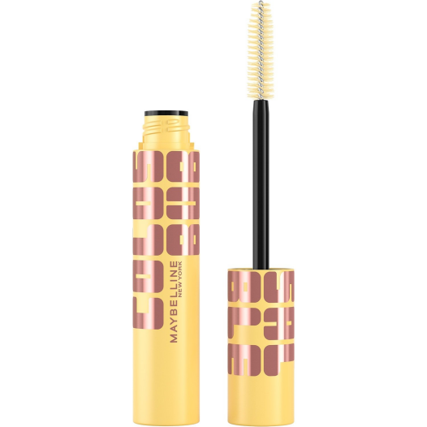

**Colossal Bubble™ Waterproof Mascara Buildable, sleek volume**

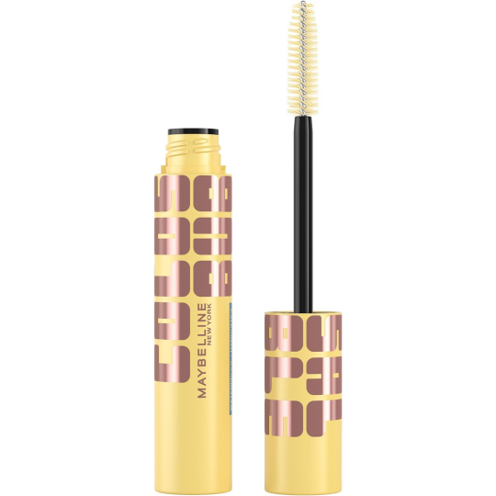

**Lash Sensational Sky High® Space Diamond Glitter Mascara Topper**

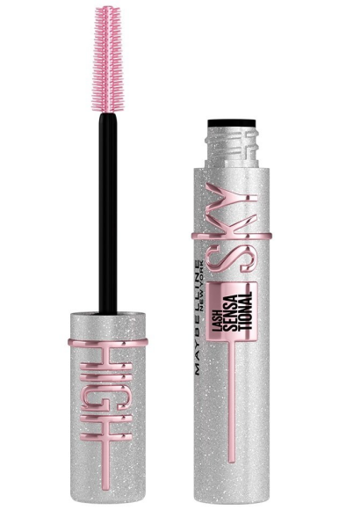

**LASH SENSATIONAL FIREWORK™ Washable Lash Flaring Mascara**

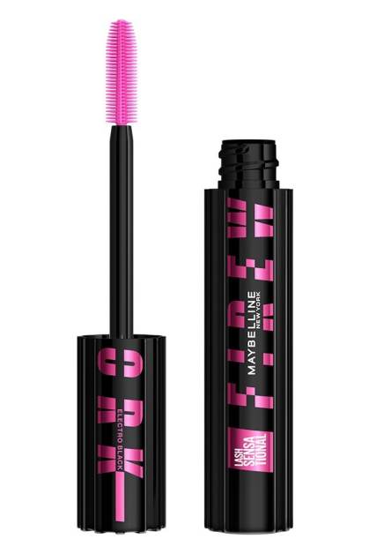

**Lash Sensational Sky High® Washable Lengthening & Volumizing Mascara**

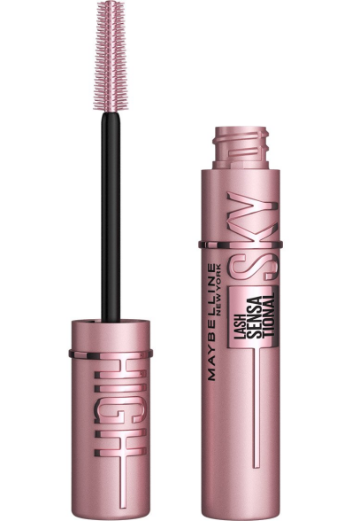

**LASH SENSATIONAL FIREWORK™ Waterproof Mascara Makeup**

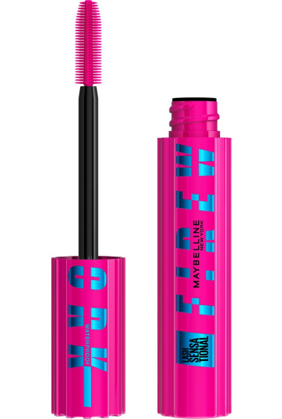

**The Falsies® Surreal Extensions Washable Mascara Eye Makeup**

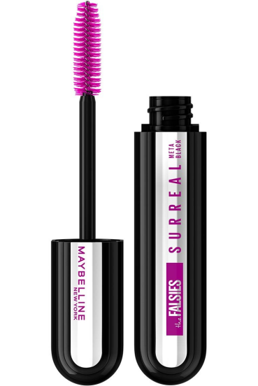

**The Falsies® Surreal Extensions Waterproof Mascara Eye Makeup**

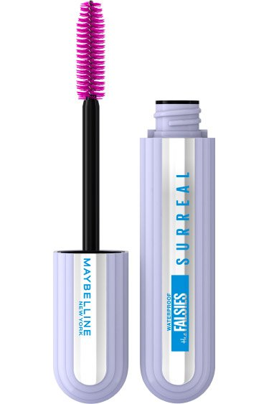

* **Eyebrows**

**Super Lock™ Brow Glue Clear & Tinted Eyebrow Gel**

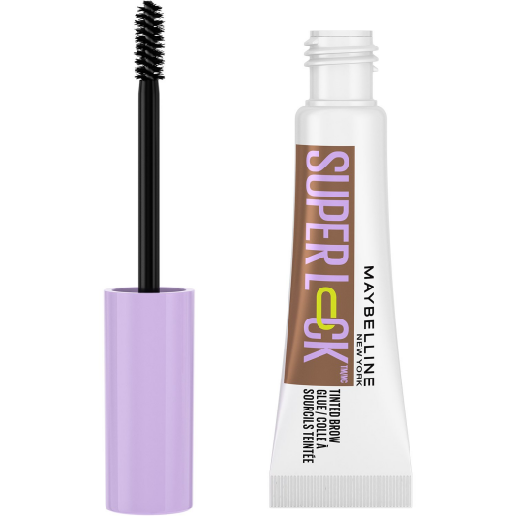

**Superfluff™ Brow Mousse**

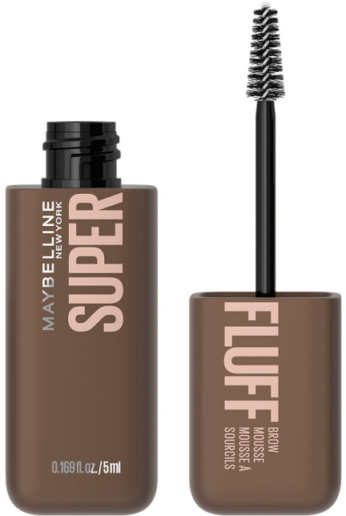

**Super Lock™ Brow Glue Clear & Tinted Eyebrow Gel**

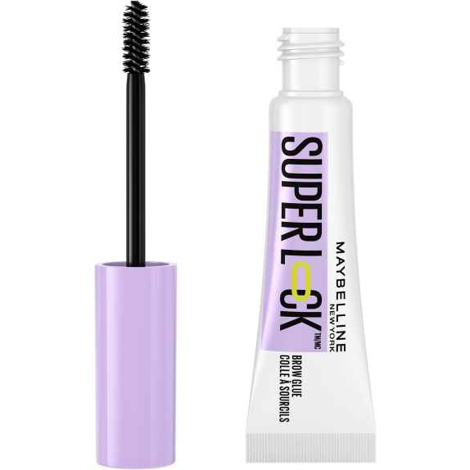

**Build-A-Brow 2-in-1 Brow Pen and Sealing Gel Eye Makeup**

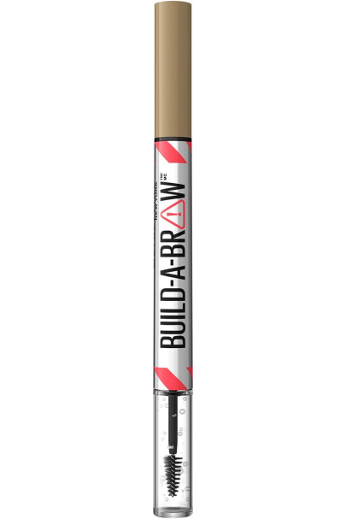

Express Brow™ Shaping Pencil Eye Makeup

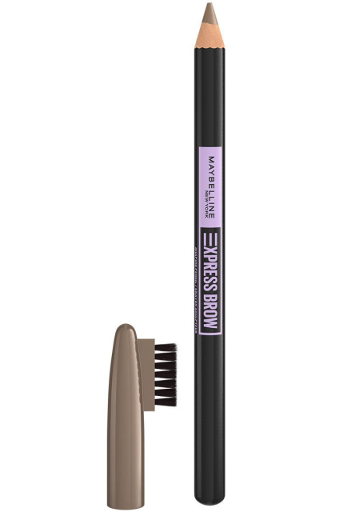

EXPRESS BROW™ DUO 2-IN-1 PENCIL AND POWDER

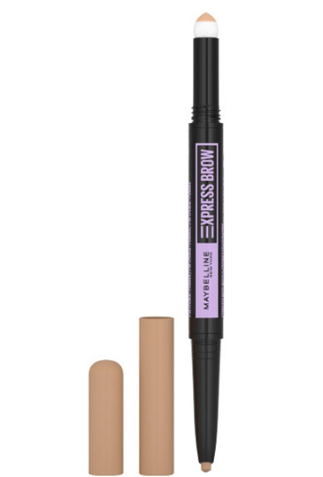

TATTOO STUDIO® WATERPROOF BROW PENCIL UP TO 36HR WEAR

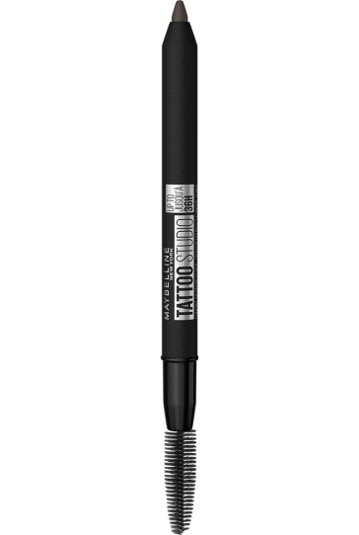

Express Brow™ Fast Sculpt™ Clear Gel Brow Mascara

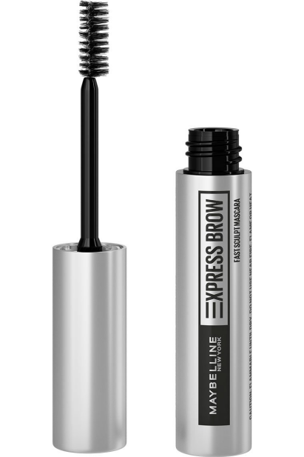

Express Brow™ Fast Sculpt™ Gel Brow Mascara

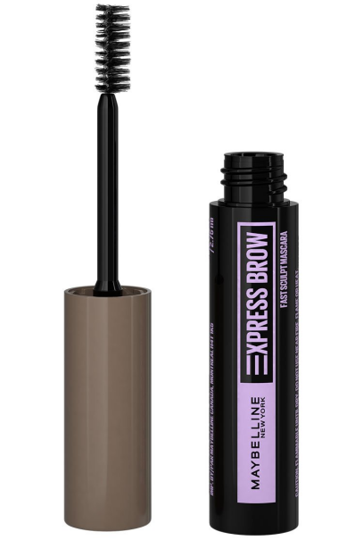

Express Brow™ Ultra Slim Defining Eyebrow Pencil

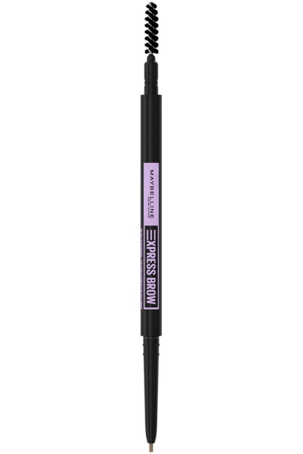

Tattoo Studio® Brow Pomade Long Lasting, Buildable Eyebrow Makeup

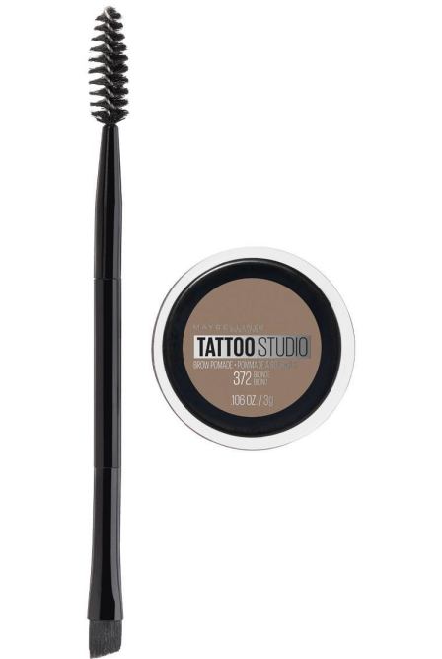

TATTOO STUDIO® BROW TINT PEN UP TO 24HR WEAR

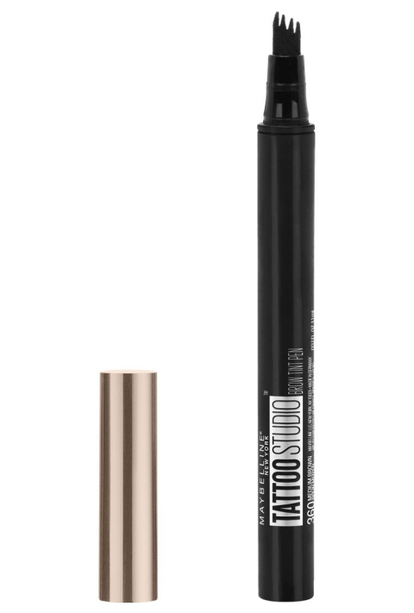

* **Eyeliners**

**Sculpting Stix Double-Ended Eyeliner Pencil with Brush**

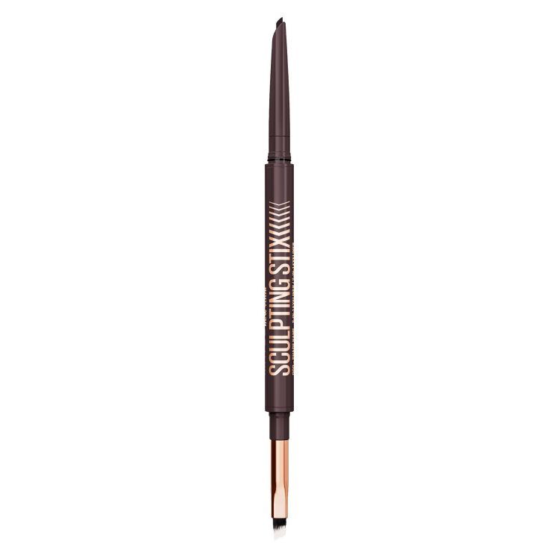

**Tattoo Studio® Dip-Ink Liquid Eyeliner**

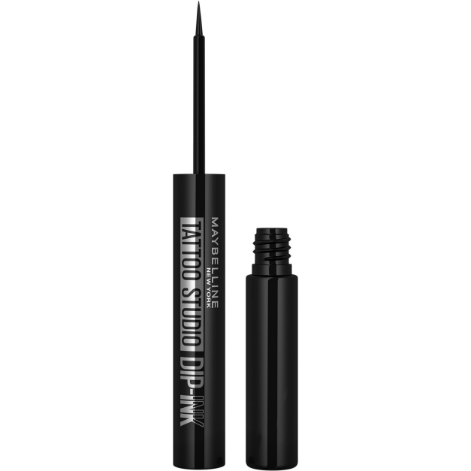

**Tattoo Studio® Sharpenable Longwear Waterproof Gel Eyeliner Pencil**

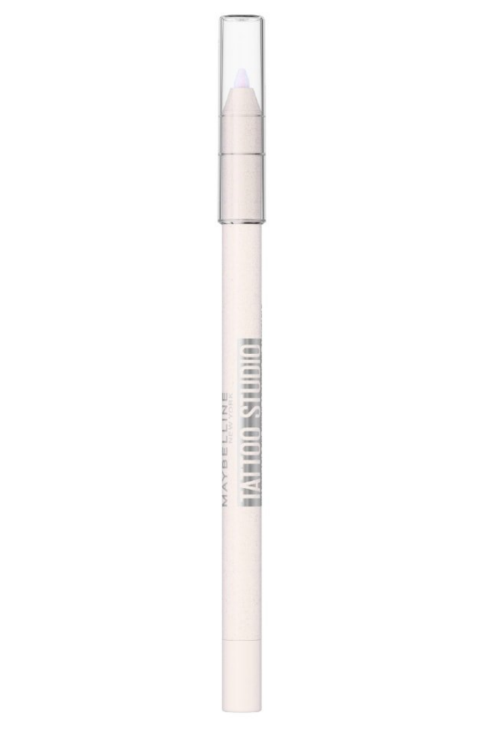

**Tattoo Studio® Ink Pen Eyeliner Makeup, Up To 24 Hours Of Wear**

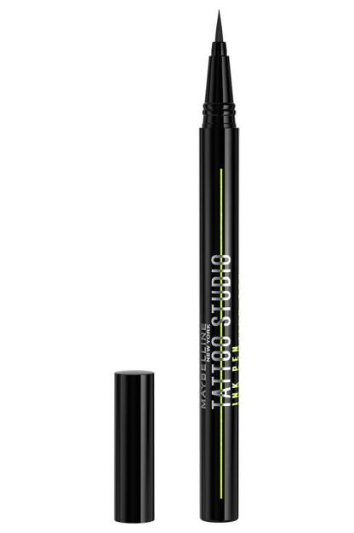

**Master Precise® All Day Liquid Eyeliner Makeup**

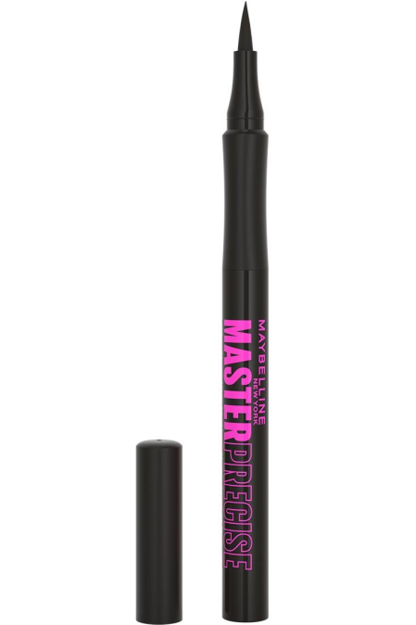

**TATTOO STUDIO® AUTOMATIC GEL PENCIL EYELINER EYE MAKEUP**

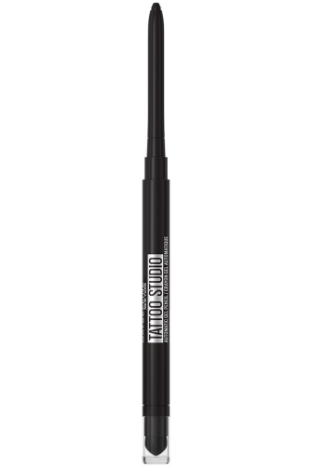

**Hyper Easy® Liquid Eyeliner, Eye Makeup**

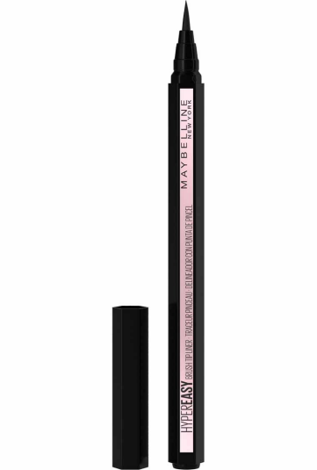

**Lasting Drama® Matte Eyeliner Makeup**

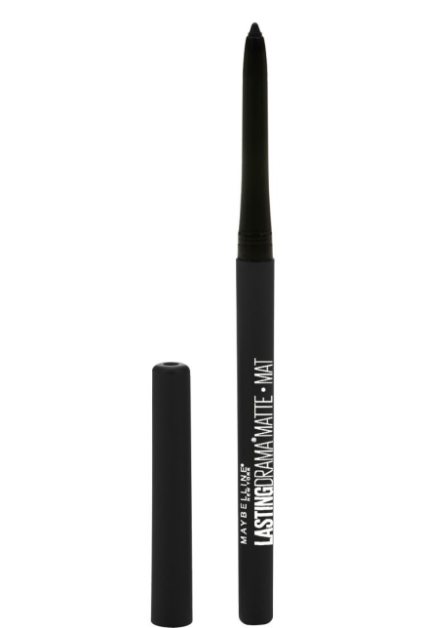

**Master Precise Ink® Metallic Liquid Eyeliner**

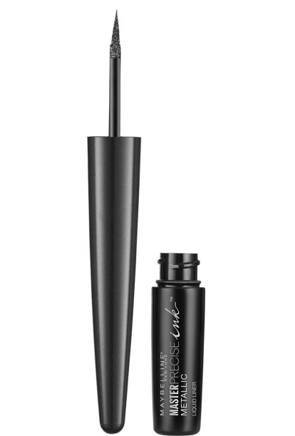

**Master Precise Skinny® Gel Pencil Eyeliner**

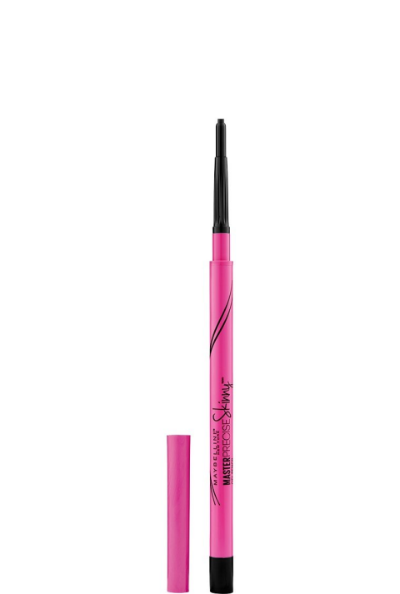

**Line Express® Sharpenable Wood Pencil Eyeliner**

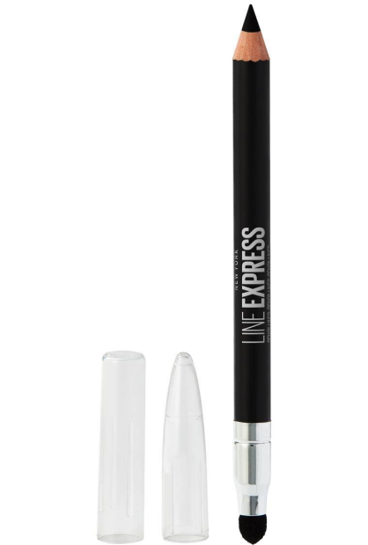

**Tattoo Studio® Gel Pot Eyeliner**

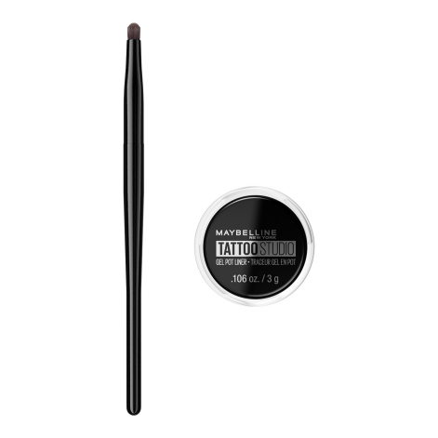

**Unstoppable® Mechanical Eyeliner Pencil**

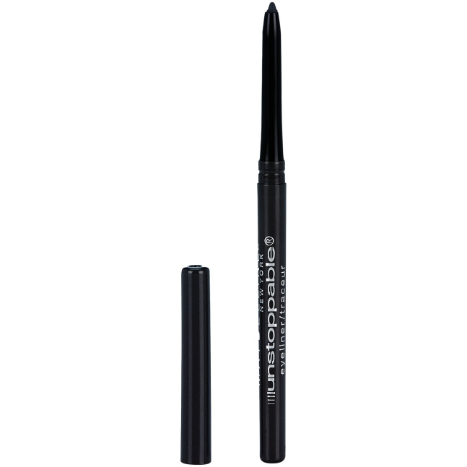

**Define-A-Line® Eye Liner Eye Makeup**

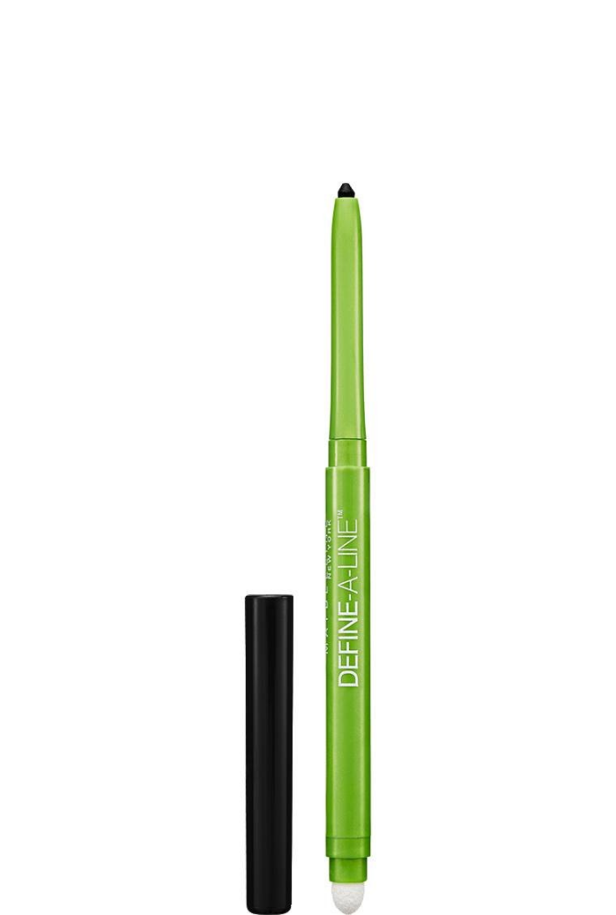

* **Eyeshadows**

**Shadow Drip Eye Tint Shimmer Liquid Eyeshadow**

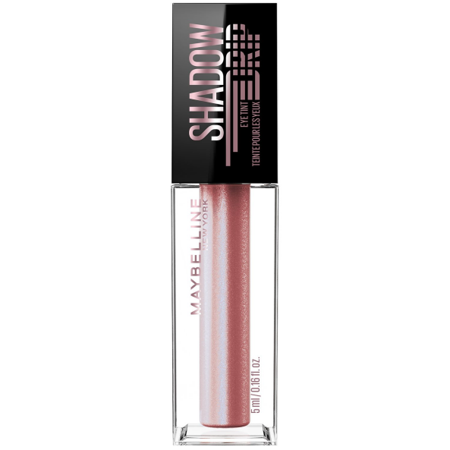

**Color Tattoo® Eye Stix Long Lasting Multi-Use Eyeshadow Stick, Liner, & Primer**

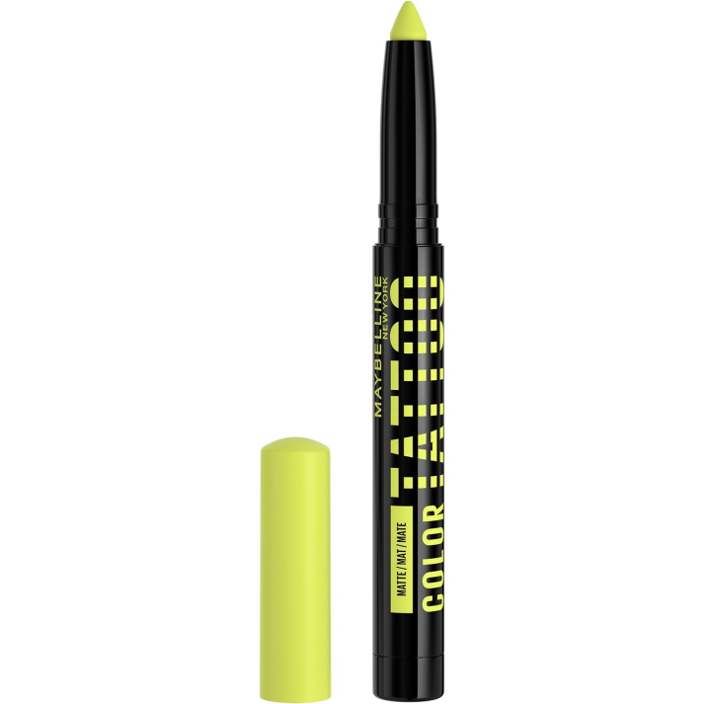

**Shadow Blocks™ Eyeshadow Palette Makeup**

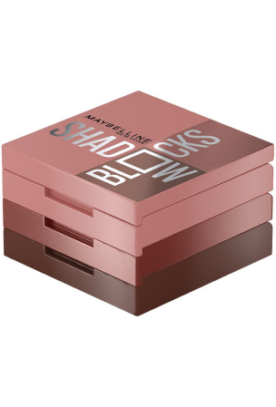

**The City Mini® Eyeshadow Palette**

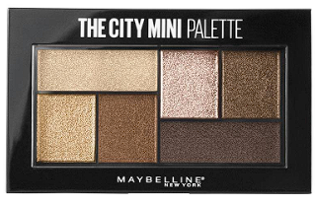

**Expert Wear® Eye Shadow**

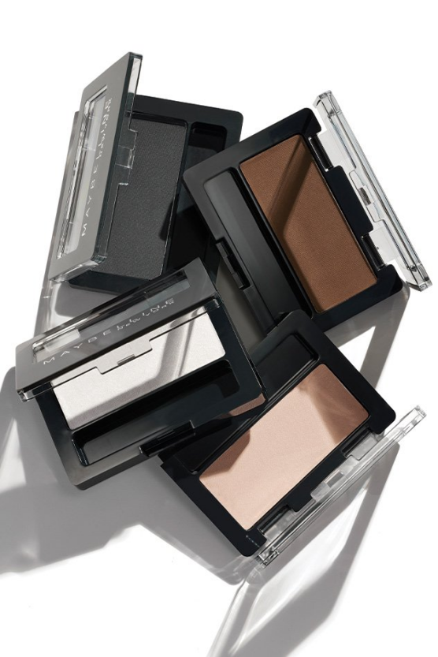

**The Nudes Eyeshadow Palette**

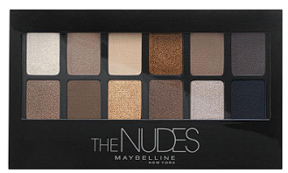

**The Blushed Nudes® Eye Shadow Palette**

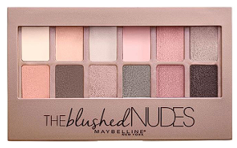

**Expert Wear® Eyeshadow Quads**

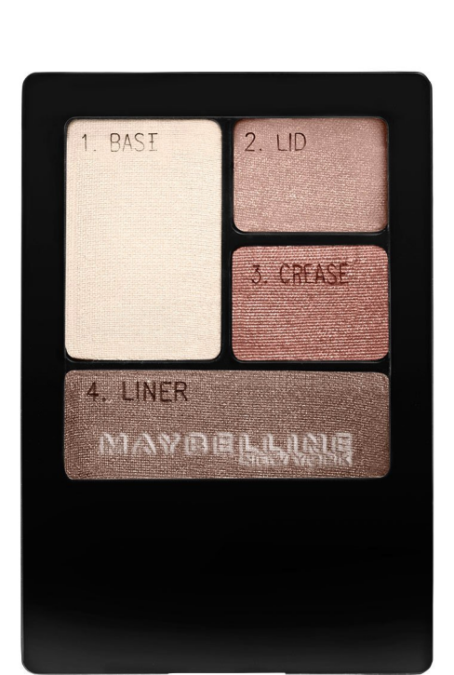

* **Lipsticks**

**Maybelline Moisturizing Serum Lipstick**

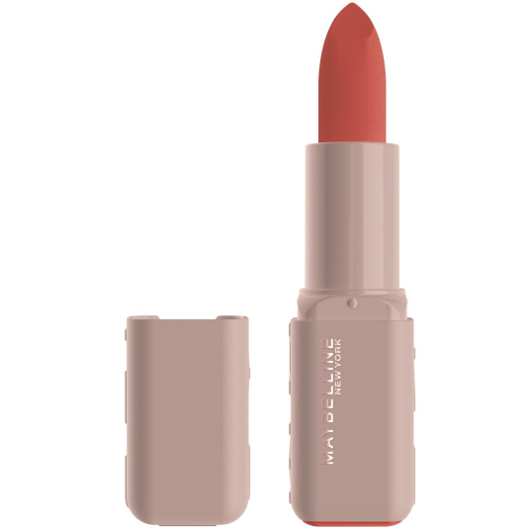

**Super Stay Teddy Tint™ LIQUID LIP TINT**

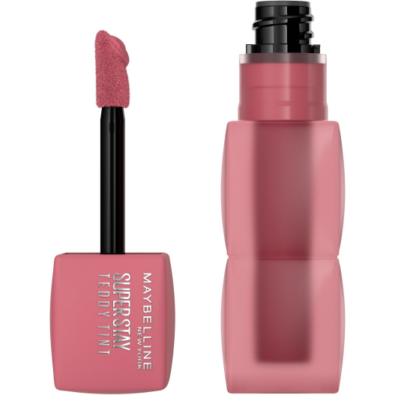

**Super Stay Matte Ink® Liquid Lipstick**

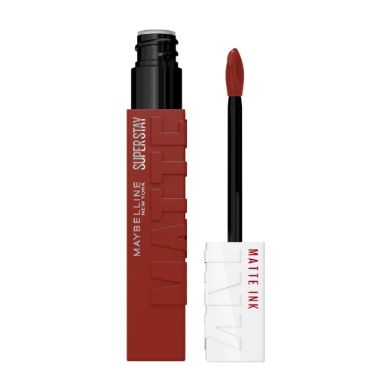

**Super Stay® Vinyl Ink® Longwear Liquid Lipcolor**

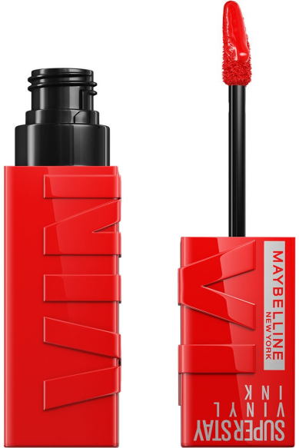

**Color Sensational® Ultimatte Slim Lipstick Makeup**

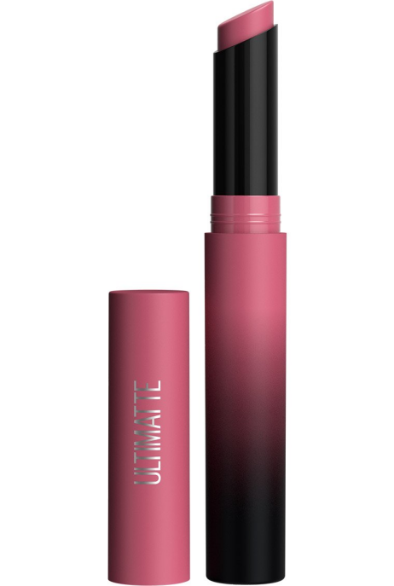

**Color Sensational® The Mattes Matte Finish Lipstick Makeup**

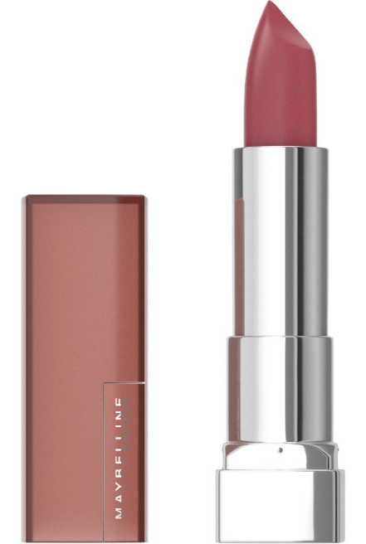

**Color Sensational® The Creams Cream Finish Lipstick Makeup**

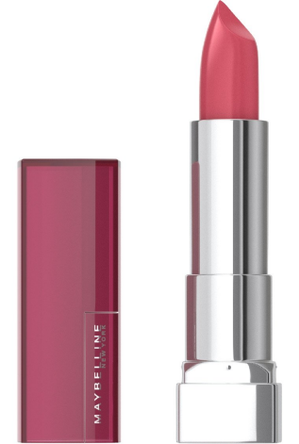

**Super Stay Ink Crayon® Lipstick Matte Longwear Lipstick Makeup**

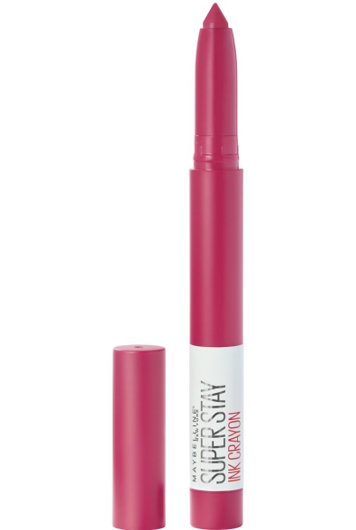

**Color Sensational® Made For All Lipstick**

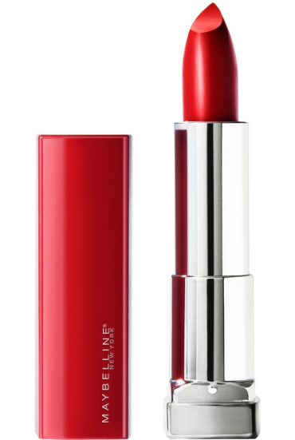

**Super Stay 24® Hour Long-Lasting 2-Step Liquid Lipstick**

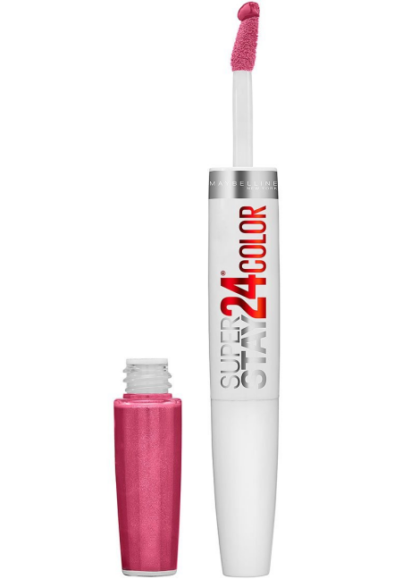

* **Lipglosses**

**Lifter Gloss® Lip Gloss Makeup With Hyaluronic Acid**

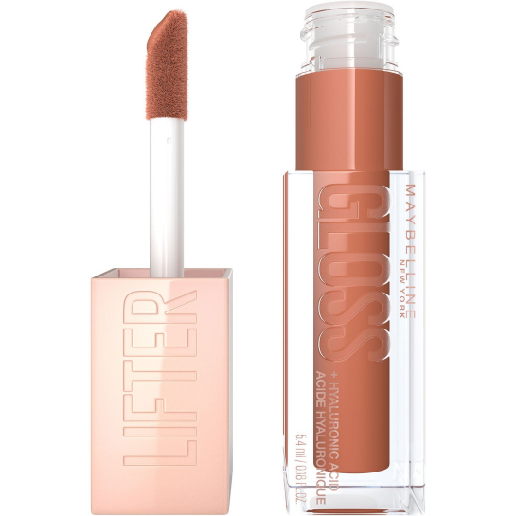

**Lifter Plump™ Lip Plumping Gloss Makeup**

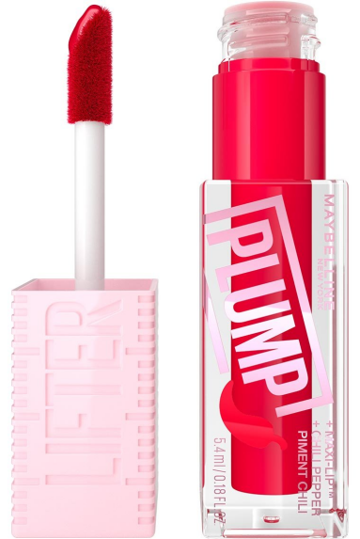

* **Lip Liners**

**LIFTER LINER™ Lip Liner Makeup with Hyaluronic Acid**

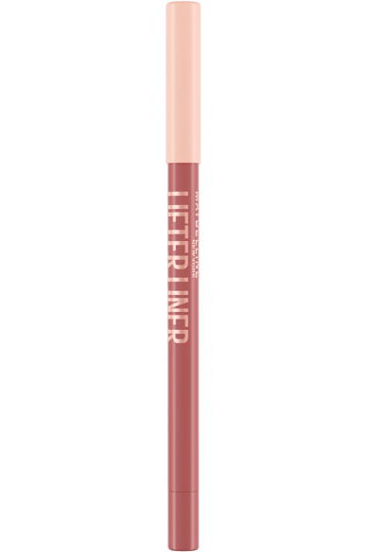

**Color Sensational® Shaping Lip Liner**

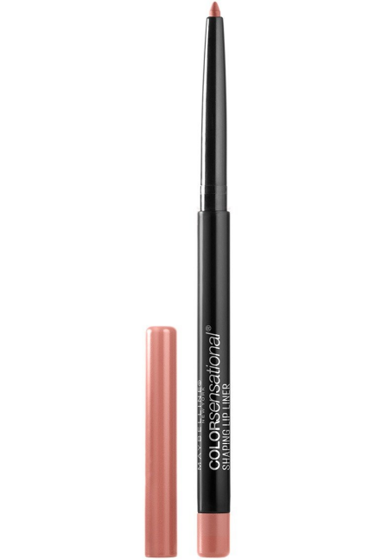

* **Lip Balms**

**LIFTER GLAZE™ LIP BALM**

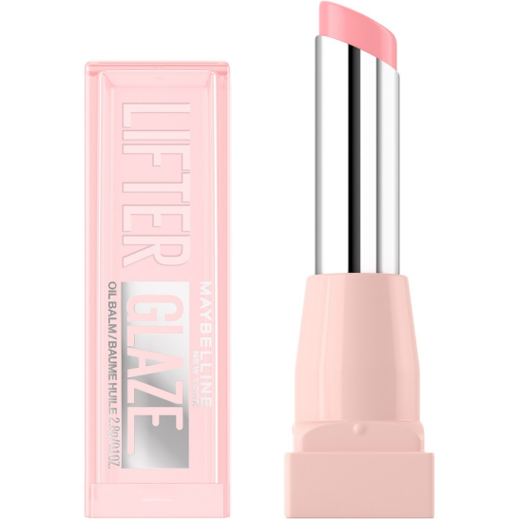

**Baby Lips Dr Rescue Medicated Lip Balm**

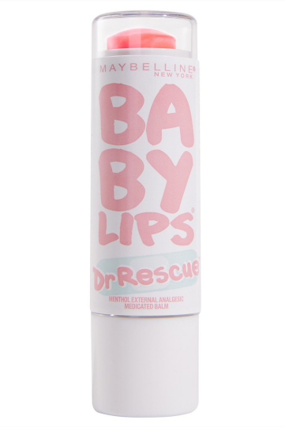

**Baby Lips® Glow Balm**

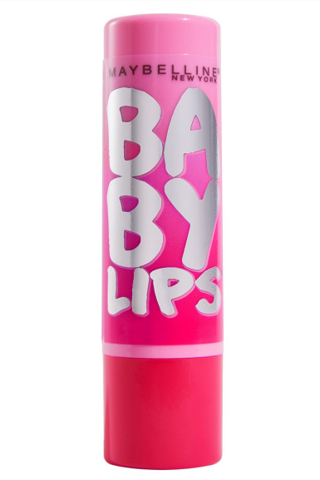

**Baby Lips® Lip Makeup Crystal Moisturizing Lip Balm**

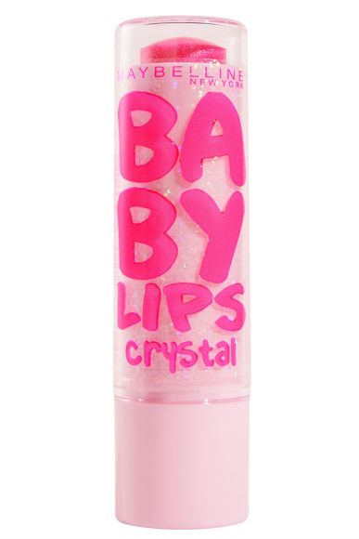

**Baby Lips® Moisturizing Lip Balm**

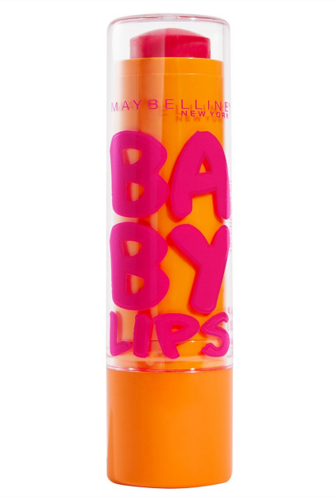

**Baby Lips® Moisturizing Lip Balm**

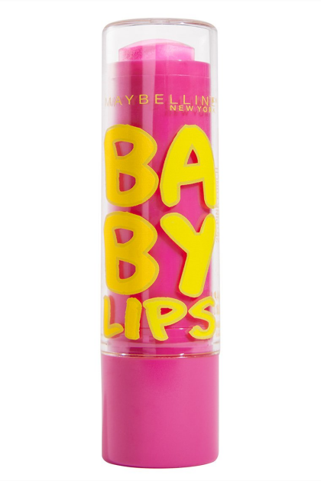

**Baby Lips® Moisturizing Lip Balm**

